1. **INTRODUCTION**

**1.1 Overview**

A BOTNET is a collection of compromised hosts (a.k.a. bots) that are remotely controlled by an attacker (the botmaster) through a command and control (C&C) channel. Botnets serve as an infrastructure responsible for a variety of cyber-crimes, such as spamming, distributed denial-of-service (DDoS) attacks, identity theft, click fraud, etc. The C&C channel is an essential component of a botnet because botmasters rely on the C&C channel to issue commands to their bots and receive information from the compromised machines. Botnets may structure their C&C channels in different ways. In a centralized architecture, all bots in a botnet contact one (or a few) C&C server(s) *owned* by the botmaster. However, a fundamental disadvantage of centralized C&C servers is that they represent a *single point of failure*. In order to overcome this problem, botmasters have recently started to build botnets with a more resilient C&C architecture, using a peer-to-peer (P2P) structure or hybrid P2P/centralized C&C structures. Bots belonging to a P2P botnet form an overlay network in which any of the nodes (i.e., any of the bots) can be used by the botmaster to distribute commands to the other peers or collect information from them.

While more complex, and perhaps more costly to manage compared to centralized botnets, P2P botnets offer higher resiliency against take-down efforts (e.g., by law enforcement), since even if a significant portion of bots in a P2P botnet are disrupted, the remaining bots may still be able to communicate with each other and with the botmaster.

**1.2 PROBLEM STATEMENT**

Designing an effective P2P-botnet detection system is faced with several challenges. This challenge is further compounded by the fact that a bot-compromised host may exhibit mixed patterns of both legitimate and botnet P2P traffic. Further, some botnets send spam through large popular webmail services such as Hotmail, which is likely transparent to network detectors due to encryption and overlap with legitimate email use patterns. Lastly, as the volume of network traffic grows rapidly, the deployed detection system is required to process a huge amount of information efficiently.

* 1. **Objectives**
* Analyzes the traffic generated by the P2P clients and classifies them into either legitimate P2P clients or P2P bots.
* Achieve high accuracy in detection bots in the network.
* Build a system that is scalable and outputs high performance even in large network.

**1.4 Motivation**

Nowadays, we have seen bots taking over the Internet on a major level. From malicious use of bots in the coordination and operation of an automated attack on networked computers, such as a denial-of-service attack by a botnet to Internet bots being used to commit click fraud and more recently have seen usage around games as computer game bots.

* The motivation for this project was primarily an interest in undertaking a challenging project in an interesting area of current problems faced during network security and detection. The opportunity to learn and work on this was a very enriching experience. It provides a great learning experience and helps us to cultivate a deep appreciation for the technology today.

**2. LITERATURE SURVEY**

**2.1 Title:** Boosting the Scalability of Botnet Detection Using Adaptive Traffic Sampling

**Author:** J. Zhang, X. Luo, R. Perdisci, G. Gu, W. Lee, and N. Feamster

**Abstract:** Most of the current network based botnet detection systems require deep packet inspection (DPI) to detect bots. The traffic can be forwarded to DPI based botnet detection systems for fine grained inspection and accurate botnet detection. This paper proposes a new packet sampling and scalable spatial-temporal flow correlation approach that aims to efficiently and effectively identify a small number of suspicious hosts that are likely bots. By using a novel adaptive packet sampling algorithm and a scalable spatial-temporal flow correlation approach, this system is able to substantially reduce the volume of network traffic that goes through DPI, thereby boosting the scalability of existing botnet detection systems.

They have implemented a proof-of-concept version of the system, and evaluated it using real world legitimate and botnet related network traces. The experimental results are very promising and suggest that this approach can enable the deployment of botnet detection systems in large, high-speed networks.

**2.2 Title:** A P2P-botnet detection model and algorithms based on network streams analysis

**Author:** D. Liu, Y. Li, Y. Hu, and Z. Liang.

**Abstract:** It is difficult to detect the peer-to-peer (P2P) botnet, hence a new method for detection based on the analysis network streams is proposed. Firstly, because the P2P streams reveal the characteristics of paroxysm and distribution, they are filtrated with streams feature for the targets to analyze. Then, according to the cohesion in a P2P network, the set of peers in a P2P network are figured. Finally, by contrasting with the common botnet actions of the peers in a P2P network, a P2P-Botnet is distinguished from a P2P networks. This paper proposes a novel real-time detecting model, MSFM (Multi-Stream Fused Model). In this model, different detecting methods based on unique characteristics of network flow packets are incorporated. Firstly, MSFM lays emphasis on the UDP flow, which is most related with the botnet C&C (Command and Control). The Hurst Parameter is used to retrieve the whole condition and detect the abnormality based on the UDP packets’ self-similarity. Secondly, MSFM applies the discrete Kalman filter to find ICMP and SMTP packets’ anomaly and Multi-chart CUSUM acts as the amplifier to make the abnormality clearer. Finally, the impact on the botnet detection which web applications generate are considered, especially the P2P applications, and use the properties of TCP flow to analyze that the abnormalities are caused by the botnets or the P2P applications. In addition, this paper uses the Kaufman algorithm to dynamically adjust the threshold to minimize the false positives and false negatives.

**2.3 Title:** Botgraph: Large scale spamming botnet detection

**Author:** G Y. Zhao, Y. Xie, F. Yu, Q. Ke, and Y. Yu

**Abstract:** In this paper, a novel system called BotGraph is designed and implemented to detect a new type of botnet spamming attacks targeting major Web email providers. BotGraph uncovers the correlations among botnet activities by constructing large user-user graphs and looking for tightly connected sub graph components. This makes it easier to identify stealthy botnet users that are hard to detect when viewed in isolation. To deal with the huge data volume, BotGraph is implemented as a distributed application on a computer cluster and a number of performance optimization techniques are explored.

This paper proposes a novel graph-based approach to detect the new Web-account abuse attacks. This approach is based on the observation that bot-users share IP addresses when they log in and send emails.

**3. REQUIREMENTS ANALYSIS**

**3.1 Software Requirements**

* **O/S :** Windows XP.
* **Language :** Java.
* **IDE :** NetBeans
* **Data Base :** MySql

**3.2 Hardware Requirements**

* **System :** Pentium IV 2.4 GHz
* **Hard Disk :** 160 GB
* **Monitor :** 15 VGA color
* **Mouse :** Logitech.
* **Keyboard :** 110 keys enhanced
* **Ram :** 2GB

**3.3 Java**

Java is a programming language originally developed by James Gosling at Sun Microsystems (now a subsidiary of Oracle Corporation) and released in 1995 as a core component of Sun Microsystems' Java platform. The language derives much of its syntax from C and C++ but has a simpler object model and fewer low-level facilities. Java applications are typically compiled to byte code (class file) that can run on any Java Virtual Machine (JVM) regardless of computer architecture. Java is a general-purpose, concurrent, class-based, object-oriented language that is specifically designed to have as few implementation dependencies as possible. It is intended to let application developers "write once, run anywhere." Java is currently one of the most popular programming languages in use, particularly for client-server web applications.

**3.4 Java Platform:**

One characteristic of Java is portability, which means that computer programs written in the Java language must run similarly on any hardware/operating-system platform. This is achieved by compiling the Java language code to an intermediate representation called Java byte code, instead of directly to platform-specific machine code. Java byte code instructions are analogous to machine code, but are intended to be interpreted by a virtual machine (VM) written specifically for the host hardware.

End-users commonly use a Java Runtime Environment (JRE) installed on their own machine for standalone Java applications, or in a Web browser for Java applets. Standardized libraries provide a generic way to access host-specific features such as graphics, threading, and networking.

A major benefit of using byte code is porting. However, the overhead of interpretation means that interpreted programs almost always run more slowly than programs compiled to native executables would. Just-in-Time compilers were introduced from an early stage that compiles byte codes to machine code during runtime.

Just as application servers such as Glass Fish provide lifecycle services to web applications, the Net Beans runtime container provides them to Swing applications. All new shortcuts should be registered in "Key maps/Net Beans" folder. Shortcuts installed INS Shortcuts folder will be added to all key maps, if there is no conflict. It means that if the same shortcut is mapped to different actions in Shortcut folder and current key map folder (like Key map/Net Beans), the Shortcuts folder mapping will be ignored.

* Database Explorer Layer API in Database Explorer

* Loaders-text-db schema-Actions in Database Explorer

* Loaders-text-sql-Actions in Database Explorer

* Plug-in Registration in Java EE Server Registry

**3.5 Net Beans**

The **Net Beans Platform** is a reusable framework for simplifying the development of Java Swing desktop applications. The Net Beans IDE bundle for Java SE contains what is needed to start developing Net Beans plug-in and Net Beans Platform based applications; no additional SDK is required.

Applications can install modules dynamically. Any application can include the Update Center module to allow users of the application to download digitally-signed upgrades and new features directly into the running application.

The platform offers reusable services common to desktop applications, allowing developers to focus on the logic specific to their application. Among the features of the platform are:

* User interface management (e.g. menus and toolbars)
* User settings management
* Storage management (saving and loading any kind of data)
* Window management
* Wizard framework (supports step-by-step dialogs)
* Net Beans Visual Library
* Integrated Development Tools

**3.6 Wamp Server**

**WAMP**s are packages of independently-created programs installed on computers that use a Microsoft Windows operating system.

Apache is a web server. MySQL is an open-source database. PHP is a scripting language that can manipulate information held in a database and generate web pages dynamically each time content is requested by a browser. Other programs may also be included in a package, such as [phpMyAdmin](http://en.wikipedia.org/wiki/PhpMyAdmin) which provides a graphical user interface for the MySQL database manager, or the alternative scripting languages Python or Perl.

**3.7 MySQL**

The MySQL development project has made its source code available under the terms of the GNU General Public License, as well as under a variety of proprietary agreements. MySQL was owned and sponsored by a single for-profit firm, the Swedish company MySQL AB, now owned by Oracle Corporation.

Free-software-open source projects that require a full-featured database management system often use MySQL. Applications which use MySQL databases include: TYPO3, [Joomla](http://en.wikipedia.org/wiki/Joomla), [WordPress](http://en.wikipedia.org/wiki/WordPress), [phpBB](http://en.wikipedia.org/wiki/PhpBB), [Drupal](http://en.wikipedia.org/wiki/Drupal) and other software built on the LAMP software stack.

Many programming languages with language-specific APIs include libraries for accessing MySQL databases. These include MySQL Connector/Net for integration with Microsoft's Visual Studio (languages such as C# and VB are most commonly used) and the JDBC driver for Java. In addition, an ODBC interface called [MyODBC](http://en.wikipedia.org/wiki/MyODBC) allows additional programming languages that support the ODBC interface to communicate with a MySQL database, such as ASP or ColdFusion. The MySQL server and official libraries are mostly implemented in ANSI C/ANSI C++.

**4. SYSTEM ANALYSIS**

**4.1 EXISTING SYSTEM**

A few approaches capable of detecting P2P botnets have been proposed, Compared with the existing methods, the design goals of our approach are different in that: our approach does not assume that malicious activities are observable; our approach does not require any botnet specific information to make the detection, our approach detects the compromised hosts that run both P2P bot and other legitimate P2P applications at the same time, Other methods use machine learning for detection, which require labeled P2P botnet data to train a statistical classifier.

**4.1.1. DISADVANTAGES:**

* A bot-compromised host may exhibit mixed patterns of both legitimate and botnet P2P traffic due to the coexistence of a file-sharing P2P application and a P2P bot on the same host.
* Modern botnets tend to use increasingly stealthy ways to perform malicious activities that are extremely hard to be observed in the network traffic. BotMiner identifies a group of hosts as bots belonging to the same botnet if they share similar communication patterns and meanwhile perform similar malicious activities, such as scanning, spamming, exploiting, etc.
* Unfortunately, the malicious activities may be stealthy and non-observable, thereby making BotMiner ineffective.

**4.2 PROPOSED SYSTEM**

In Proposed system, aim at detecting all hosts within the monitored network that engage in P2P communications. And also we analyze raw traffic collected at the edge of the monitored network and apply a pre-filtering step to discard network flows that are unlikely to be generated by P2P applications. We first apply a flow clustering process. The distance between two flows is subsequently defined as the Euclidean distance of their two corresponding vectors. Two P2P bots in the same botnet should have small distance and thus are connected at lower level (forming a dense cluster). In contrast, legitimate P2P applications tend to have large distances and consequently are connected at the upper level.

**4.2.1. ADVANTAGES:**

* In proposed System our system analyzes the traffic generated by the P2P clients and classifies them into either legitimate P2P clients or P2P bots.
* It identifies the performance bottleneck of our system and optimize its scalability.
* Our proposed system accomplishes high accuracy on detecting stealthy P2P bots and great scalability.
* It provides both high detection accuracy and great scalability of the proposed system.

**5. SYSTEM DESIGN**

A P2P botnet relies on a P2P protocol to establish a C&C channel and communicate with the botmaster. Therefore P2P bots exhibit some network trafﬁc patterns that are common to other P2P client applications (either legitimate or malicious). Thus, the system is divided into two phases. The ﬁrst phase aims to detect all hosts within the monitored network that engage in P2P communications. As shown in Figure 5.1, the raw trafﬁc collected is analyzed at the edge of the monitored network and a pre-ﬁltering step is applied to discard network ﬂows that are unlikely to be generated by P2P applications. The remaining trafﬁc is then analyzed and a number of statistical features are extracted to identify ﬂows generated by P2P clients. In the second phase, the system analyzes the trafﬁc generated by the P2P clients and classiﬁes them into either legitimate P2P clients or P2P bots. Speciﬁcally, the active time of a P2P client is investigated and identified as a candidate P2P bot if it is persistently active on the underlying host. Further, the overlap of peers contacted by two candidate P2P bots are analyzed to ﬁnalize detection.

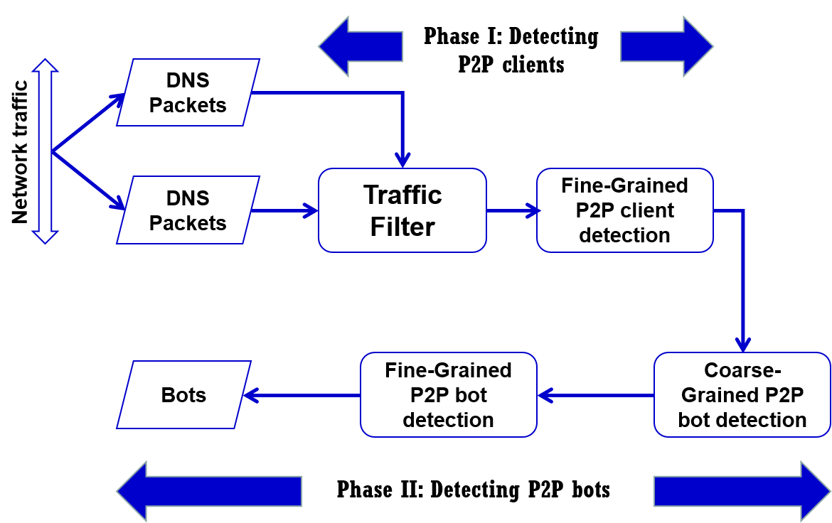

**Figure 5.1: System overview**

The different stages of detecting a botnet are:

* 1. Identifying P2P clients
     1. Traffic Filter
     2. Fine-Grained Detection of P2P Clients
  2. Detecting P2P Bots
     1. Coarse-Grained Detection of P2P Bots
     2. Fine-Grained Detection of P2P Bots
  3. **Identifying P2P Clients**
     1. **Trafﬁc Filter:**

The Trafﬁc Filter component aims at ﬁltering out network trafﬁc that is unlikely to be related to P2P communications. This is accomplished by passively analyzing DNS trafﬁc, and identifying network ﬂows whose destination IP addresses were previously resolved in DNS responses. P2P clients usually contact their peers directly by looking up IPs from a routing table for the overlay network, rather than resolving a domain name. A small fraction of ﬂows are corresponding to a possible exception that a peer bootstraps into a P2P network by looking up domain names that resolve to stable super-nodes. Since most non-P2P applications (e.g., browsers, email clients, etc.) often connect to a destination address resulting from domain name resolution, this simple ﬁlter can eliminate a very large percentage of non-P2P trafﬁc, while retaining the vast majority of P2P communications.

* + 1. **Fine-Grained Detection of P2P Clients:**

This component is responsible for detecting P2P clients by analyzing the remaining network ﬂows after the Trafﬁc Filter component. For each host h within the monitored network we identify two ﬂow sets, denoted as Stcp(h) and Sudp(h), which contain the ﬂows related to successful outgoing TCP and UDP connection, respectively. In order to detect P2P clients, we ﬁrst consider the fact that each P2P client frequently exchanges control messages (e.g., ping/pong messages) with other peers. Besides, we notice that the characteristics of these messages, such as the size and frequency of the exchanged packets, are similar for nodes in the same P2P network and vary depending on the P2P protocol and network in use. As a consequence, if two network ﬂows are generated by the same P2P application and they carry the same type of P2P control messages, they tend to share similar ﬂow size. In addition, a P2P client will exchange control messages with a large number of peers distributed in many different networks. Consequently, the destination IP addresses of network ﬂows that carry these control messages will spread across a large number of networks. To identify ﬂows corresponding to P2P control messages, a ﬂow clustering process intended to group similar ﬂows for each candidate P2P node h together is applied. Given sets of ﬂows Stcp(h) and Sudp(h), each ﬂow using a vector of statistical features is characterized as (1)

v(h) = [Pkts, Pktr, Bytes, Byter]. . . . . . . . . . . . . . . . . . . . . (1)

where, Pkts and Pktr represent the number of packets sent and received, Bytes and Byter represent the number of bytes sent and received, respectively. The distance between two ﬂows is subsequently deﬁned as the Euclidean distance of their two corresponding vectors. A clustering algorithm is applied to partition the set of ﬂows into a number of clusters. Each of the obtained clusters of ﬂows, Cj(h), represents a group of ﬂows with similar size. For each Cj(h), a set of destination IP addresses related to the ﬂows in the clusters are considered. Therefore, each host h can now be described by a set of ﬁngerprint clusters as (2)

FC(h) ={FC1, . . . ,FCk}. . . . . . . . . . . . …. . . . . . . . (2)

A h is labelled as P2P node if FC(h) =∅, i.e., h should have generated at least one ﬁngerprint cluster. Figure 5.1 illustrates an example of the ﬂow clustering process for a P2P node. Flows corresponding to TCP and UDP share similar sizes, and hence they are grouped into two clusters (FC1 and FC2), respectively. A ﬁngerprint cluster summary (Pkts, Pktr, Bytes, Byter, proto), represents the protocol and the average number of sent/received packets/bytes for all the ﬂows in this ﬁngerprint cluster.

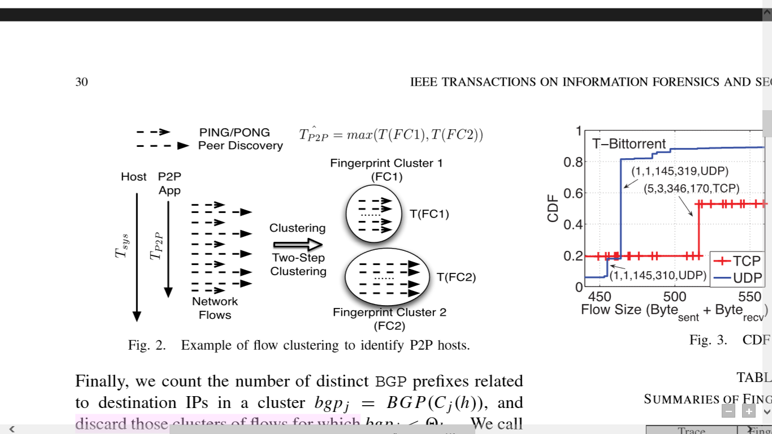

**Figure 5.2: An example of Fingerprint clustering**

* 1. **Detecting P2P Bots** 
     1. **Coarse-Grained Detection of P2P Bots:**

Since bots are malicious programs used to perform proﬁtable malicious activities, they represent valuable assets for the botmaster, who will intuitively try to maximize utilization of bots. This is particularly true for P2P bots because in order to have a functional overlay network (the botnet), a sufﬁcient number of peers needs to be always online. In other words, the active time of a bot should be comparable with the active time of the underlying compromised system. If this was not the case, the botnet overlay network would risk degenerating into a number of disconnected subnetworks due to the short life time of each single node. In contrast, the active time of legitimate P2P applications is determined by users, which is likely to be transient. For example, some users tend to use their ﬁle-sharing P2P clients only to download a limited number of ﬁles before shutting down the P2P application. In this case, the active time of the legitimate P2P application may be much shorter compared to the active time of the underlying system. It is worth noting that some users may run certain legitimate P2P applications for as long as their machine is on. For example, Skype is a popular P2P application for instant messaging and voice-over-IP (VoIP) that is often setup to start after system boot, and that keeps running until the system is turned off. Therefore, such Skype clients (or other “persistent” P2P clients) will not be ﬁltered out at this stage. Hence, the ﬁrst component in the “Phase II” of the system (Coarse-Grained Detection of P2P Bots) aims at identifying P2P clients that are active for a time TP2P close to the active time TSYS of the underlying system they are running on. While this behavior is not unique to P2P bots, this feature helps identifying persistent P2P clients.

The following procedure is followed to estimate TSYS:

* For each host h ∈ H that are identiﬁed as P2P clients, the timestamp tstart(h) of the ﬁrst network ﬂow that is observed from h and the timestamp tend(h) related to the last ﬂow we have seen from h is considered.
* The time tend(h)−tstart(h) is divided into w epochs (e.g., of one hour each), denoted as

T =[ t1,...ti,...,tw] . . . . . . . . . . . . . . . . . . . . …. . . . . . . . . (3)

* Further, a vector A(h,T) =[ a1, . . . ai, . . . , aw] . . . . . . . . . . . . …. . . . . . . . . (4)

is computed, where ai =1 if h generated any network trafﬁc between ti −1 and ti.

* Estimate the active time of h as TSYS =∑ ai. . . . . . . . . . . . . …. . . . . . . . . . . . . . . . (5)
* For each host h, the set of its ﬁngerprint clusters is examined by

FC(h) ={FC1, . . . FCj . . . ,FCk}. . . . . . . . . . . . . . . . . . . . . . . (6)

* Estimate the active time (TP2P) of a P2P application.
* Host h will then be input to next step, where h will be represented by a set of persistent ﬁngerprint clusters for h, denoted as

FCp(h)={FCik , . . . , FCj k}. . .. . . . . . . . . . . . . . . . . . . . . . . (7)

Where T(FCi)/ TSYS >TP2P for any FCi ∈ FCp(h).

* + 1. **Fine-Grained Detection of P2P Bots:**

The objective of this component is to identify P2P bots from all persistent P2P clients (i.e., set P). The one feature that is leveraged is: the overlap of peers contacted by two P2P bots belonging to the same P2P botnet is much larger than that contacted by two clients in the same legitimate P2P network. Assume that two hosts in the monitored network, say hA and hB, are running the same legitimate P2P ﬁle-sharing application (e.g., Emule). Users of these two P2P clients will most likely have uncorrelated usage patterns. It is reasonable to assume that in the general case the two users will search for and download different content (e.g., different media ﬁles or documents) from the P2P network. This translates into a divergence between the set of IP addresses contacted by hosts hA and hB. The reason is that the two P2P clients will tend to exchange P2P control messages (e.g., ping/pong and search requests) with different sets of peers which “own” the content requested by their users, or peers that are along the path towards the content. On the contrary, if hA and hB are compromised with P2P bots, one common characteristic of bots is that they need to periodically search for commands published by the botmaster. This typically translates into a convergence between the set of IPs contacted by hA and hB. In order to leverage this feature, each host

h ∈ P is represented using its persistent ﬁngerprint clusters

FCp(h) ={FC1, . . . ,FCk}. . . . . . . . . . . . . . . . . . . . . (8)

Each ﬁngerprint cluster FCi is converted to a vector [Bytes,i, Byter,i, πi]. In this vector, Bytes,i (Bytes,i) is the average number of bytes sent (received) per ﬂow in FCi, πi is a set that contains the destination IP addresses (peers) of the ﬂows in FCi. Further two distance functions are defined below ( (9) and (10) ), where FCi(a)and FCj(b) represent two ﬁngerprint clusters from two persistent P2P clients, hA and hB, respectively.

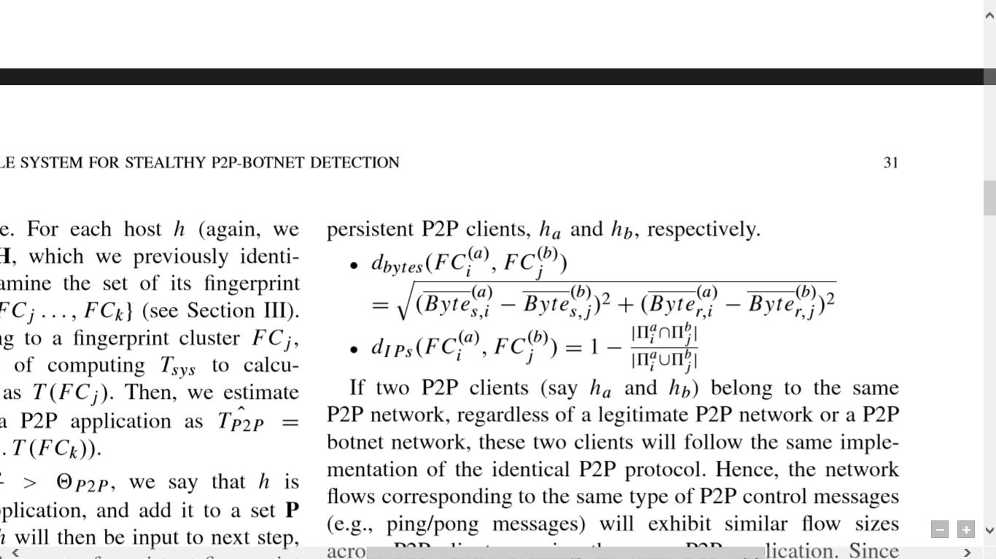. . . . . . . . . . . . . . .(9)

. . . . . . . . . . . . . . . . . . . . . . . . . . (10)

If two P2P clients (say hA and hB) belong to the same P2P network, regardless of a legitimate P2P network or a P2P botnet network, these two clients will follow the same implementation of the identical P2P protocol. Hence, the network ﬂows corresponding to the same type of P2P control messages (e.g., TCP/UDP) will exhibit similar ﬂow sizes across P2P clients running the same P2P application. Since a ﬁngerprint cluster summarizes network ﬂows for the same type of control messages in one client, two ﬁngerprint clusters corresponding to the same P2P control messages belonging to the same P2P application will have similar ﬂow size. In other words, two P2P clients from the same P2P network will share at least one pair of ﬁngerprint clusters (FCi(a), FCj(b)), which have a small value of dbytes(FCi(a), FCj(b)) since they are corresponding to the same P2P control message. Otherwise, if two P2P clients belong to different P2P networks, dbytes tends to be large.

Given two P2P bots (say hA and hB) belonging to the same botnet, the sets of peers contacted by these two bots, denoted as πia and πjb, will share a large overlap, thereby generating a small value of dIPs(FCi(a), FCj(b)). Otherwise, if two P2P clients belong to the same legitimate P2P network or different P2P networks, they will share a small overlap and produce a large value of dIPs(FCi(a), FCj(b)).

Further a distance function dist(hA hB) is defined to quantify the similarity of two P2P clients by integrating dbytes and dIPs. dist(hA hB) tends to yield a small value if hA and hB are infected with bots from the same P2P botnet. Especially, even if hA and hB are infected with P2P bots from the same botnet and they run legitimate P2P applications simultaneously, the distance quantiﬁed by dist(hA hB) will be small. It is because that at least one pair of ﬁngerprint clusters that are generated by P2P bots will yield small values for both dbytes and dIPs.

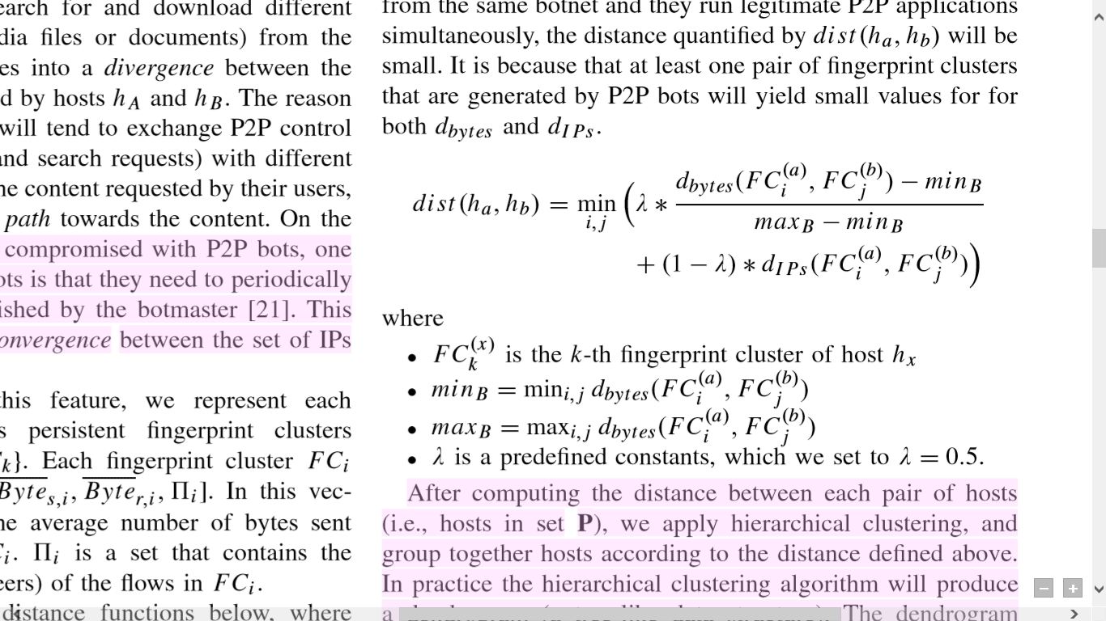. . . . . . . . . . . . . . . . (11)

After computing the distance between each pair of hosts (i.e., hosts in set P), hierarchical clustering is applied and the hosts are grouped according to the distance deﬁned above. In practice the hierarchical clustering algorithm will produce a dendrogram (a tree-like data structure). The dendrogram expresses the “relationship” between hosts. The closer two hosts are, the lower they are connected at in the dendrogram. Two P2P bots in the same botnet should have small distance and thus are connected at lower level (forming a dense cluster). In contrast, legitimate P2P applications tend to have large distances and consequently are connected at the upper level. The hosts in the dense clusters are identified as P2P bots, and all other clusters are discarded while the related hosts are classified as legitimate P2P clients.

* 1. **Data flow diagrams**

A data flow diagram or DFD is a graphical representation of the "flow" of data through an information system, modelling its process aspects. The DFD is also called as bubble chart. Often they are a preliminary step used to create an overview of the system which can later be elaborated. DFDs can also be used for the visualization of data processing or structured designing. Data flow diagram shows what kinds of information will be input to and output from the system, where the data will come from and go to, and where the data will be stored. It does not show information about the timing of processes, or information about whether processes will operate in sequence or in parallel.

* + 1. **Description**

A Data Flow Diagram (DFD) tracks processes and their data paths within the business or system boundary under investigation. A DFD defines each domain boundary and illustrates the logical movement and transformation of data within the defined boundary. The diagram shows 'what' input data enters the domain, 'what' logical processes the domain applies to that data, and 'what' output data leaves the domain. Essentially, a DFD is a tool for process modelling and one of the oldest.

* + 1. **Uses of DFDs**

A Data Flow Diagram is useful for establishing the boundary of the business or system domain (the sphere of analysis activity) under investigation.

It identifies any external entities along with their data interfaces that interact with the processes of interest.

A DFD can be a useful tool for helping secure stakeholder agreement (sign-off) on the project scope

* + 1. **Levels of abstraction**

In order to fashion an accurate picture of anything, we need to employ various levels of abstraction. This need arises from the basic relationship between an object and an observer, or a subject and its student. There are qualitative changes, as one move from one level of abstraction to the next, however, and seemingly a progression of form and/ or formative principles. Thus the process of abstraction itself becomes part of the picture, or one of the formative elements thereof.

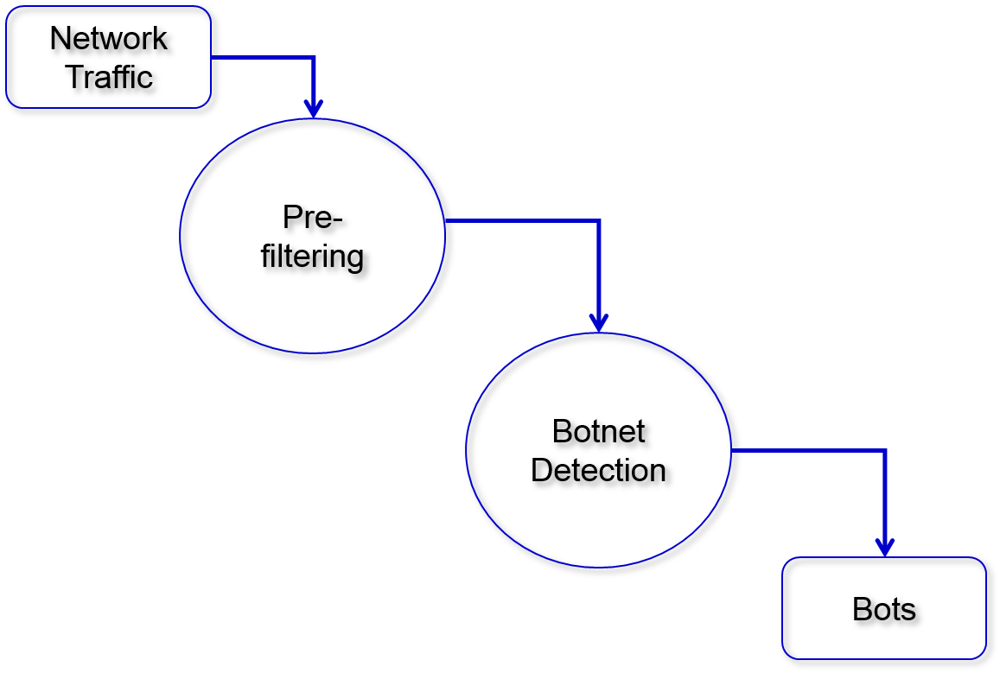

**Figure 5.3.3.1: DFD Level 0**

Figure 5.3.3.1 shows the level 0 of DFD. Level 0 DFD is the highest level of abstraction where one or two bubbles represent the complete system. Here, the input(s) going to a process is different from the output(s) leaving the process. The input to the system is a set of clients from the network traffic. The set of clients taken from the network undergo pre-filtering phase first and then proceed to Botnet detection. The output obtained is a network of bots present in the network.

Figure 5.3.3.2 shows the next level of abstraction i.e., DFD level 1. Level 1 DFD must balance with level 0 DFD. Level 1 DFD shows how the system is divided into sub-systems (processes) and also shows the flow of data between the various parts of the system. The system takes P2P clients in the network as its initial input. These clients go through the *Traffic Filtering* stage where those clients that are not P2P are filtered out. The output of this stage is a set of P2P clients that are either legitimate clients or bots. Further, *Fine Grained P2P Client Detection* technique is used to remove the possibility of any client that is not P2P in the filtered set. These P2P clients go through *Coarse Grained Bot Detection* technique and *Fine Grained Bot Detection* technique to distinguish legitimate P2P Clients from P2P Bots.

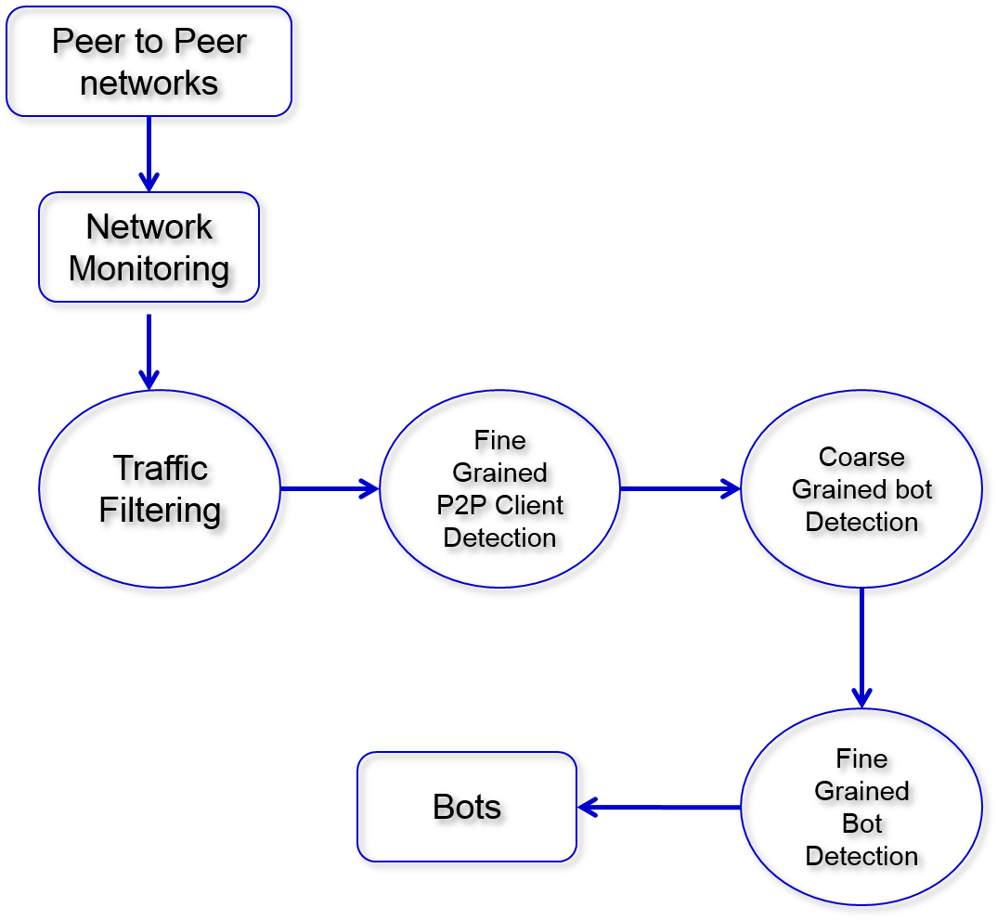

**Figure 5.3.3.2: DFD Level 1**

A more detailed explanation of the system can be shown in the next level of abstraction i.e., Level 2 DFD. Level 2 DFD must balance with Level 1 DFD. Level 2 DFD gives a detailed description of each sub-system mentioned in Level 1 DFD. Level 2 DFD is shown in the figure 5.3.3.3.

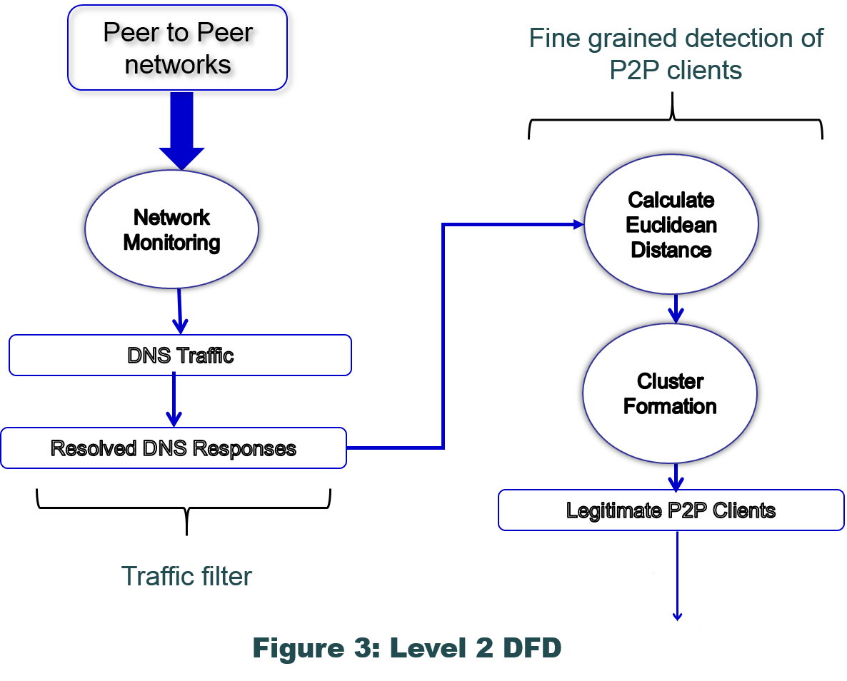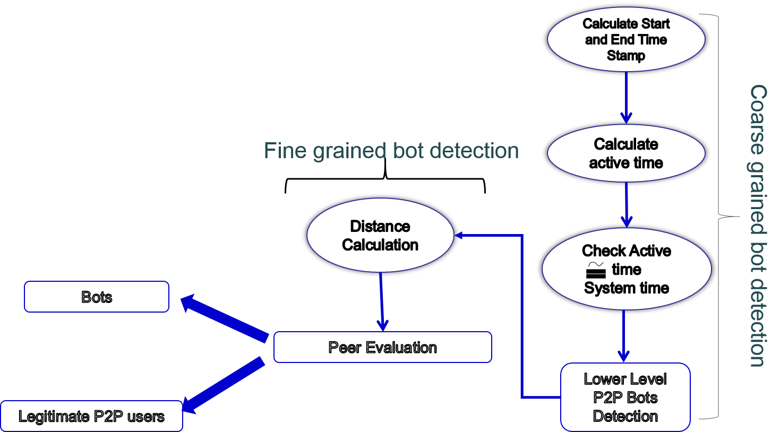

**Figure 5.3.3: DFD Level 2**

With a closer look at the system, the complete system comes to light. The whole system is majorly divided into four stages. The stages are *Traffic filter*, *Fine Grained Detection of P2P clients*, *Coarse Grained Detection of P2P Bots* and *Fine Grained Detection of P2P Bots*. Each stage has its input and its output. The inputs and outputs to each of this stages are not the same. In Traffic Filtering stage, the input is a set of Clients present in the network traffic. Here, majority of the clients that are not P2P are filtered out. In the next stage, any non-P2P clients that are still present will be identified and ignored using the clustering technique. The output from second stage is a set of P2P clients that are either P2P bots or legitimate P2P clients. The final two stages distinguish P2P clients from P2P bots. The third stage identifies the legitimate P2P clients by considering the active time of the P2P clients and the active time of the underlying system. A client is considered as a bot if the active time of the client is comparable with the active time of the underlying system. Those clients that have comparable active time with the underlying system are retained and the rest are ignored. Further, some legitimate applications (such as, Skype) may be active on the system since the time the system was active. The fourth stage identifies those P2P clients that fall under this category. Finally, at the end of the fourth stage, a set of P2P bots are derived.

* 1. **Use case diagram**

To model a system the most important aspect is to capture the dynamic behavior to clarify a bit in detail. In Unified Modelling Language (UML) there are five diagrams to model dynamic nature. Use case diagram is one of them.

A use case diagram is a representation of user’s interaction with the system. A use case diagram can portray the different types of users of a system and the various ways that they interact with the system. In use case diagram, ovals represents processes and arrows indicate interaction. Use case diagram should include the following:

* Functionalities to be represented as an use case
* Actors
* Relationships among the use cases and actor

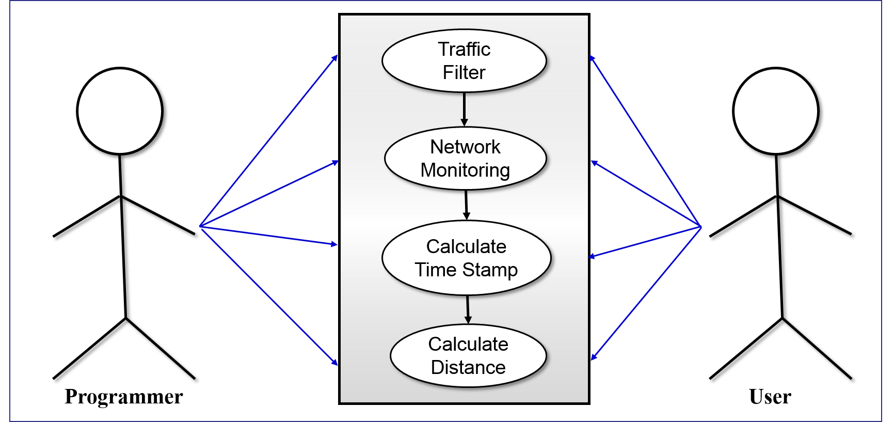

**Figure 5.4.1 :** Use case diagram

* + 1. **Programmer’s view:**

1. The system takes network traffic as input
2. The system identifies DNS packets as Non P2P Clients
3. Non P2P clients are eliminated
4. Using the Euclidean formula, Euclidean distances are calculated for every client present
5. Based on the distances calculated, the clients are grouped into clusters for each node
6. For every node, the clusters are summarized
7. Timestamp for every node is calculated
8. Active time of the client and the active time of the host system are compared with respect to the summarized values
9. Those clients with comparable active times are retained and the rest are ignored (assumed to be legitimate P2P clients)
10. In the remaining set of clients, legitimate P2P clients are identified and ignored
11. The clients that remain after filtering are considered as the bots present in the system
    * 1. **User’s view:**
12. The system takes its input from the network traffic
13. Majority of the Non-P2P clients are eliminated
14. Minority of the Non-P2P clients are eliminated
15. P2P clients (bots and legitimate users) are identified
16. Few of the P2P legitimate Clients are identified and ignored
17. The legitimate P2P clients that are still present in the cluster are identified and ignored
18. The remaining Clients are the Bots present in the system
    1. **Sequence Diagram**

A sequence diagram also called as event diagrams, event scenarios, and timing diagrams shows the object interactions arranged in time sequence. It depicts the objects and classes resolved in the scenario and the sequence of messages exchanged between the objects proceeded to carry out the functionality of the scenario.

A sequence diagram shows, as parallel vertical lines (lifelines), different processes or objects that live simultaneously, and, as horizontal arrows, the messages exchanged between them, in the order in which they occur.

Steps followed in the sequence diagram:

1. The system takes network traffic as input
2. The system identifies DNS packets as Non P2P Client
3. Non P2P clients are eliminated
4. Using the Euclidean formula, Euclidean distances are calculated for every client present
5. Based on the distances calculated, the clients are grouped into clusters for each node
6. For every node, the clusters are summarized
7. Timestamp for every node is calculated
8. Active time of the client and the active time of the host system are compared with respect to the summarized values
9. Those clients with comparable active times are retained and the rest are ignored (assumed to be legitimate P2P clients)
10. In the remaining set of clients, legitimate P2P clients are identified and ignored
11. The clients that remain after filtering are considered as the bots present in the system

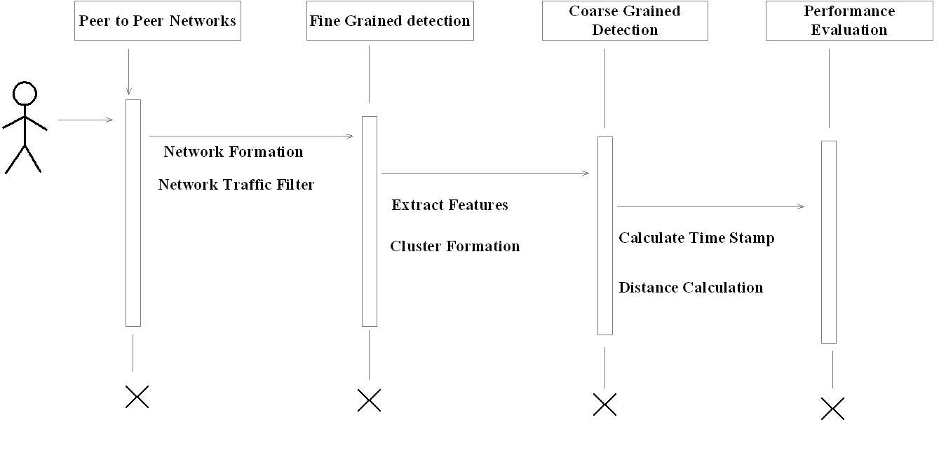

1. **Implementation**

We begin the implementation with traffic filtering, which eliminates all Non-P2P Clients. Followed by Fine grained P2P clients where those Non-P2P clients that escaped the traffic filter stage are eliminated here. This is followed by Coarse grained detection of P2P Bots where most of the legitimate P2P clients are identifies and eliminated. Finally the few legitimate P2P clients present are identified and eliminated in Fine grained P2P Bot detection. Those hosts that are left after the filtering process are the bots present in the system.

**6.1 Module description**

We have four modules in this project and they are:

1. Traffic Filtering

a) Network Monitoring

b) DNS Traffic

2. Fine Grained Detection of P2P Clients

a) Cluster Formation based on protocol

3. Coarse Grained Detection of P2P Bots

a) Calculate Start and End Time Stamp

b) Calculate Active time

c) Compare Active time with System time

. 4. Fine Grained Detection of P2P Bots

a) Euclidean Distance Calculation

b) Peer Evaluation

**6.2. Algorithm and detailed explanation for each module**

**6.2.1. Traffic Filtering**

This module will accept the input from the network traffic. The input will be a set of hosts present in the network and these hosts include P2P clients, P2P Bots and Non-P2P traffic. The Trafﬁc Filter component aims at ﬁltering out network trafﬁc that is unlikely to be related to P2P communications. This is accomplished by passively analyzing DNS trafﬁc, and identifying network ﬂows whose destination IP addresses were previously resolved in DNS responses and then eliminating it from the system.

ALGORITHM

Input: Network traffic

Output: DNS Traffic Eliminated from the initial input traffic

Step 1: Start.

Step 2: Check if all the hosts in input have IP addresses

Step 3: Eliminate those hosts that were resolved in DNS responses previously

Step 4: Stop.

**6.2.2 Fine Grained Detection of P2P Clients**

This component is responsible for detecting P2P clients by analyzing the remaining network ﬂows after the Trafﬁc Filter component. Each of the host is classified into clusters based on the network flow (TCP or UDP). Once all the hosts are grouped into clusters, the Euclidean distance between the two flows are calculated for each host. The average distance for each of the cluster is calculated and summarized. If the average distance does not exceed a certain threshold value, then the corresponding host is discarded.

ALGORITHM

Input: Network traffic that contain only those hosts with a legitimate IP address

Output: P2P clients (including Bots and legitimate clients) are retained

Step 1: Start.

Step 2: Consider the filtered traffic after the Traffic Filter module

Step 3: Group the nodes into clusters based on the network flows (TCP/UDP)

Step 4: Calculate Euclidean Distance for each of the network flow

Step 5: Discard those clusters whose distance is less than a threshold value

Step 6: Stop

**6.2.3 Coarse Grained Detection of P2P Bots**

The output from the previous model will have only those clients that are P2P. This component is responsible for identifying the bots. The active time of each client is calculated. Also, the system time of the underlying host is calculated. By comparing the active time and the system time, the P2P clients can be distinguished from the bots. The feature that is leveraged is that, a client that has its active time comparable with the system time is a bot as a bot must be active on the system for a long time to listen to the system communication. Those clients that have active time not comparable with the system are identified as legitimate P2P clients and are discarded.

ALGORITHM

Input: P2P clients (including Bots and legitimate clients)

Output: Legitimate P2P clients

Step 1: Start.

Step 2: Calculate Active time of P2P clients

Step 3: Calculate system time of the underlying host

Step 4: Identify those hosts whose active time is not comparable with the host system time

Step 5: Discard the identified hosts

Step 6: Stop

**6.2.3 Fine Grained Detection of P2P Bots**

ALGORITHM

Input:

Output:

Step 1: Start.

Step 2:

Step 3:

Step 4:

Step 5: Stop

**6.4 System implementation**

Implementation of software refers to the final installation of the package in its real environment, to the satisfaction of the intended users and the operation of the system.

* The active user must be aware of the benefits of using the system
* Proper guidance is impaired to the user so that he is comfortable in using the application

Before going ahead and viewing the system, the user must know that for viewing the result, the server program should be running in the server. If the server object is not running on the server, the actual processes will not take place.

**6.4.1. User Training**

To achieve the objectives and benefits expected from the proposed system it is essential for the people who will be involved to be confident of their role in the new system. As system becomes more complex, the need for education and training is more and more important. Education is complementary to training. It brings life to formal training by explaining the background to the resources for them. Education involves creating the right atmosphere and motivating user staff. Education information can make training more interesting and more understandable.

**6.4.2. Training on the Application Software**

After providing the necessary basic training on the computer awareness, the users will have to be trained on the new application software. This will give the underlying philosophy of the use of the new system such as the screen flow, screen design, type of help on the screen, type of errors while entering the data, the corresponding validation check at each entry and the ways to correct the data entered. This training may be different across different user groups and across different levels of hierarchy.

**6.4.3. Operational Documentation**

Once the implementation plan is decided, it is essential that the user of the system is made familiar and comfortable with the environment. A documentation providing the whole operations of the system is being developed. Useful tips and guidance is given inside the application itself to the user. The system is developed user friendly so that the user can work the system from the tips given in the application itself.

**6.5. System Maintenance**

The maintenance phase of the software cycle is the time in which software performs useful work. After a system is successfully implemented, it should be maintained in a proper manner. System maintenance is an important aspect in the software development life cycle. The need for system maintenance is to make adaptable to the changes in the system environment. There may be social, technical and other environmental changes, which affect a system which is being implemented. Software product enhancements may involve providing new functional capabilities, improving user displays and mode of interaction, upgrading the performance characteristics of the system. So only thru proper system maintenance procedures, the system can be adapted to cope up with these changes. Software maintenance is of course, far more than “finding mistakes”.

**6.5.1. Corrective Maintenance**

The first maintenance activity occurs because it is unreasonable to assume that software testing will uncover all latent errors in a large software system. During the use of any large program, errors will occur and be reported to the developer. The process that includes the diagnosis and correction of one or more errors is called Corrective Maintenance.

**6.5.2. Adaptive Maintenance**

The second activity that contributes to a definition of maintenance occurs because of the rapid change that is encountered in every aspect of computing. Therefore Adaptive maintenance termed as an activity that modifies software to properly interfere with a changing environment is both necessary and commonplace.

**6.5.3. Perceptive Maintenance**

The third activity that may be applied to a definition of maintenance occurs when a software package is successful. As the software is used, recommendations for new capabilities, modifications to existing functions, and general enhancement are received from users. To satisfy requests in this category, Perceptive maintenance is performed. This activity accounts for the majority of all efforts expended on software maintenance.

**6.5.4. Preventive Maintenance**

The fourth maintenance activity occurs when software is changed to improve future maintainability or reliability, or to provide a better basis for future enhancements. Often called preventive maintenance, this activity is characterized by reverse engineering and re-engineering techniques.

1. **Test Cases**

**7.1. Introduction**

The purpose of testing is to discover errors. Testing is the process of trying to discover every conceivable fault or weakness in a work product. It provides a way to check the functionality of components, sub-assemblies, assemblies and/or a finished product. It is the process of exercising software with the intent of ensuring that the Software system meets its requirements and user expectations and does not fail in an unacceptable manner. There are various types of test. Each test type addresses a specific testing requirement.

* 1. **Types of Testing**
     1. **Unit Testing**

Unit testing involves the design of test cases that validate that the internal program logic is functioning properly, and that program inputs produce valid outputs. All decision branches and internal code flow should be validated. It is the testing of individual software units of the application. It is done after the completion of an individual unit before integration. This is a structural testing, that relies on knowledge of its construction and is invasive. Unit tests perform basic tests at component level and test a specific business process, application, and/or system configuration. Unit tests ensure that each unique path of a business process performs accurately to the documented specifications and contains clearly defined inputs and expected results.

* + 1. **Functional Test**

Functional tests provide systematic demonstrations that functions tested are available as specified by the business and technical requirements, system documentation, and user manuals.

Functional testing is centered on the following items:

Valid Input : identified classes of valid input must be accepted.

Invalid Input : identified classes of invalid input must be rejected.

Functions : identified functions must be exercised.

Output : identified classes of application outputs.

Systems/Procedures: interfacing systems or procedures must be invoked.

Organization and preparation of functional tests is focused on requirements, key functions, or special test cases. In addition, systematic coverage pertaining to identify Business process flows; data fields, predefined processes, and successive processes must be considered for testing. Before functional testing is complete, additional tests are identified and the effective value of current tests is determined.

* + 1. **System Test**

System testing ensures that the entire integrated software system meets requirement. It tests a configuration to ensure known and predictable results. An example of system testing is the configuration oriented system integration test. System testing is based on process descriptions and flows, emphasizing pre-driven process links and integration points.

* + 1. **White Box Testing**

White Box Testing is a testing in which in which the software tester has knowledge of the inner workings, structure and language of the software, or at least its purpose. It is purpose. It is used to test areas that cannot be reached from a black box level.

* + 1. **Black Box Testing**

Black Box Testing is testing the software without any knowledge of the inner workings, structure or language of the module being tested. Black box tests, as most other kinds of tests, must be written from a definitive source document, such as specification or requirements document, such as specification or requirements document.

**Test Objectives**

* All field entries must work properly.
* Pages must be activated from the identified link.
* The entry screen, messages and responses must not be delayed.

# Integration Testing

Software integration testing is the incremental integration testing of two or more integrated software components on a single platform to produce failures caused by interface defects. The task of the integration test is to check that components or software applications, e.g. components in a software system or – one step up – software applications at the company level – interact without error.

* + 1. **Acceptance Testing**

User Acceptance Testing is a critical phase of any project and requires significant participation by the end user. It also ensures that the system meets the functional requirements.

The program to detect the botnet was executed successfully. The modules involved namely Traffic filter, Fine Grained Detection of Clients, Coarse Grained Detection of Bots and Fine Grained Detection of Bots were tested together to detect the bots in the network. The results of the executed program have been tabulated as follows.

|  |  |  |  |  |  |
| --- | --- | --- | --- | --- | --- |
| **Sl no.** | **Test Cases** | **Input** | **Actual Output** | **Expected Output** | **Result**  **Status** |
| 1 | Pre-filtering of network traffic | Network traffic routing table information | Only P2P client names and IPs present in routing table | Only P2P clients name and IPs present in routing table | Pass |
| 2 | Peer Communication | Send test file from the source | Receives file in the destination | Receives file in the destination | Pass |
| 3 | Cluster  formation | All nodes’ communication information | Clusters formed based on similar flow size | Clusters formed based on similar flow size | Pass |
| 4 | Coarse grained bot detection | Cluster formation | Persistent applications | Persistent applications | Pass |
| 5 | Fine grained bot detection | Persistent application | Bots and legitimate clients | Bots and legitimate clients | Pass |

Figure 7.1: Test Cases

1. **Result**

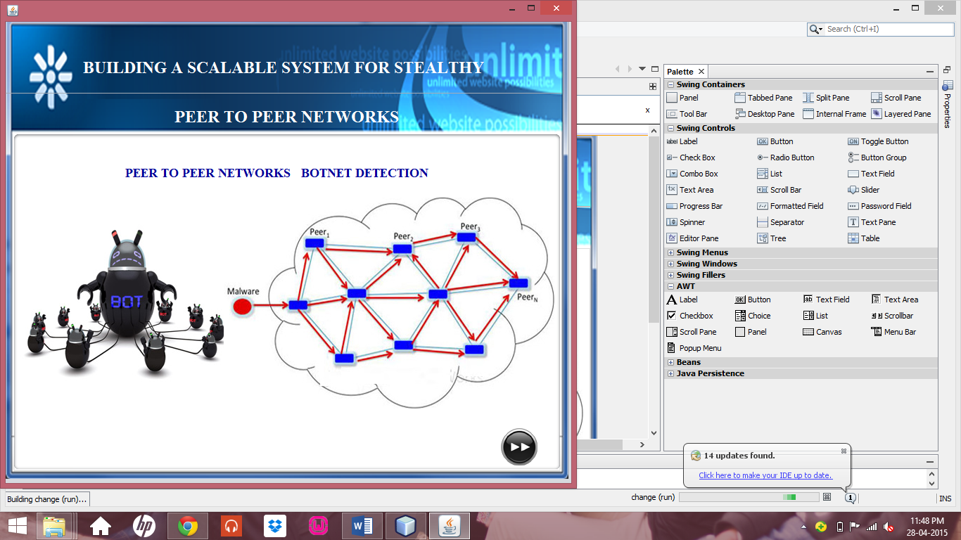

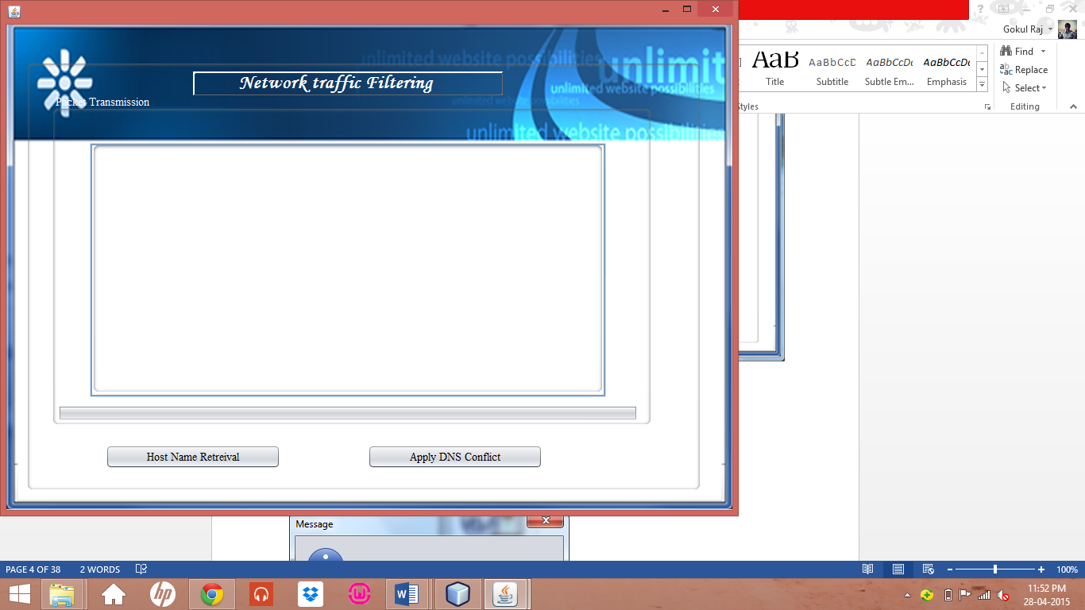

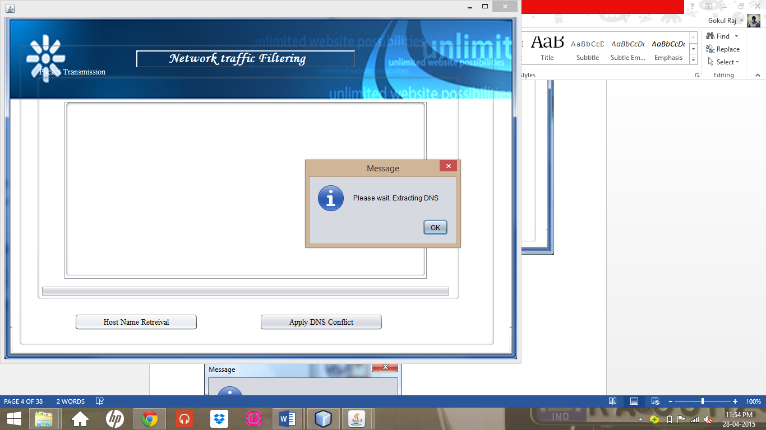

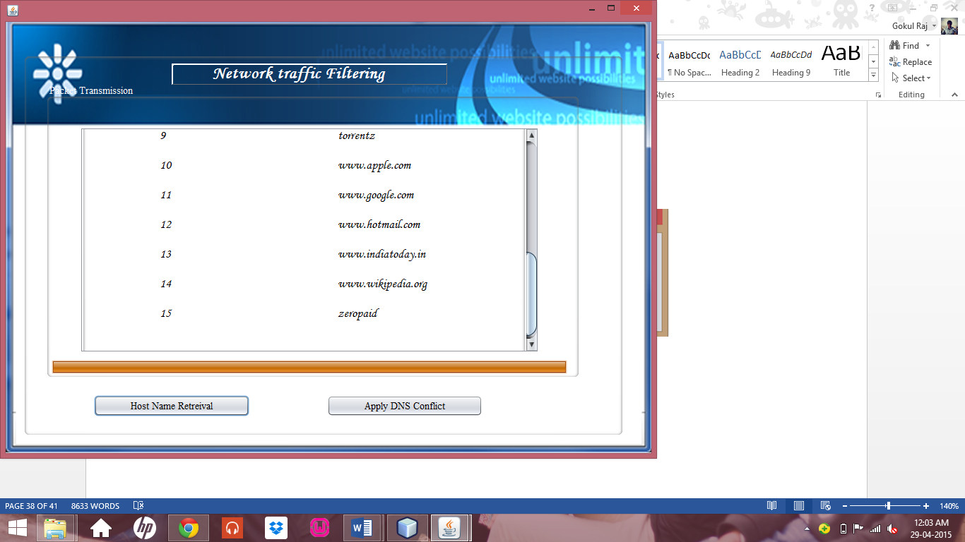

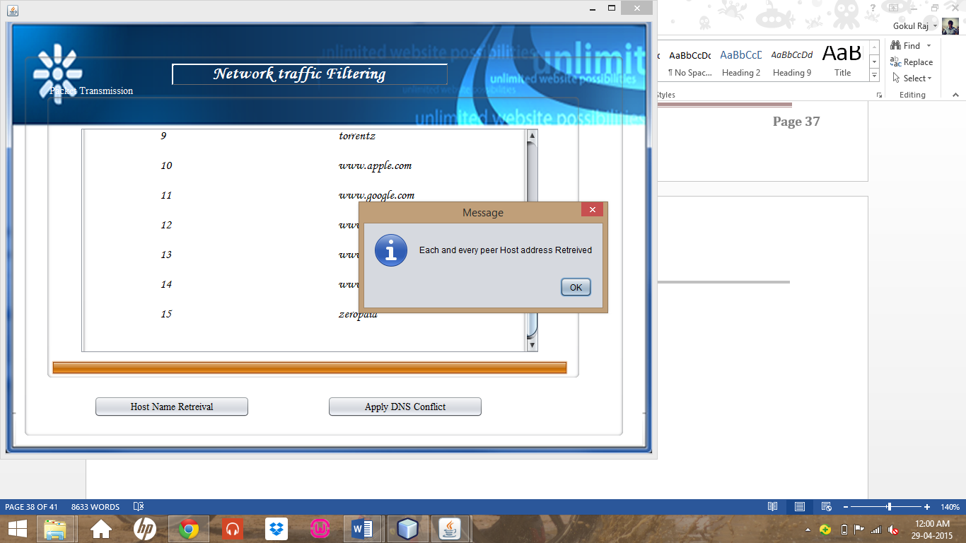

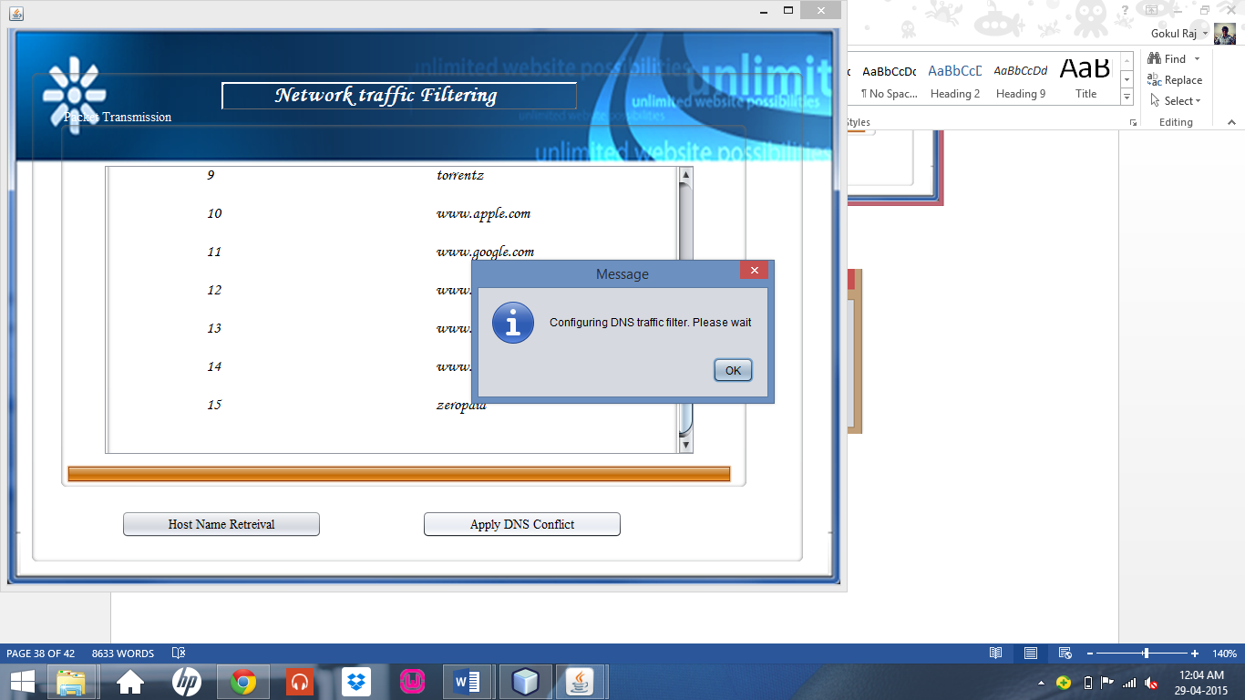

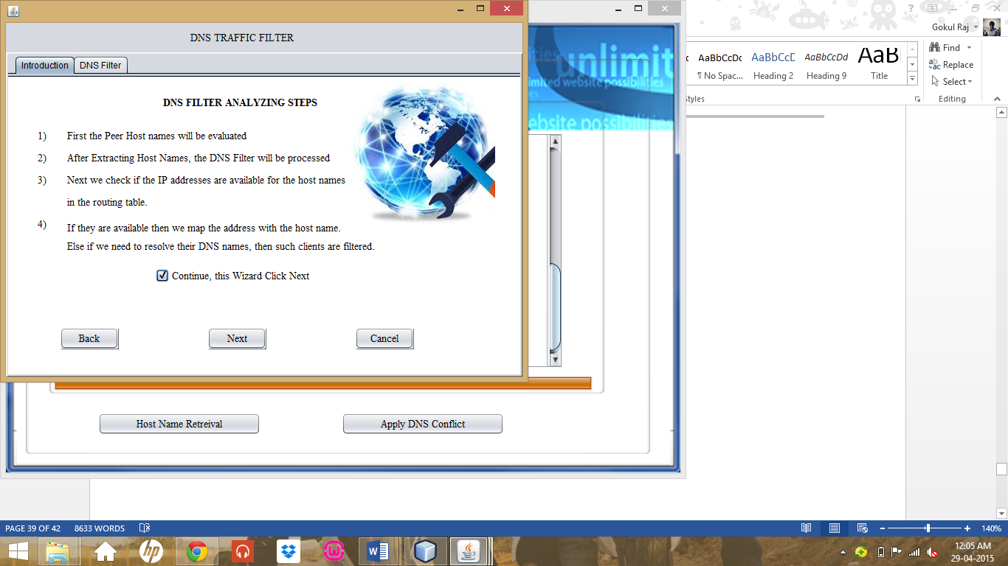

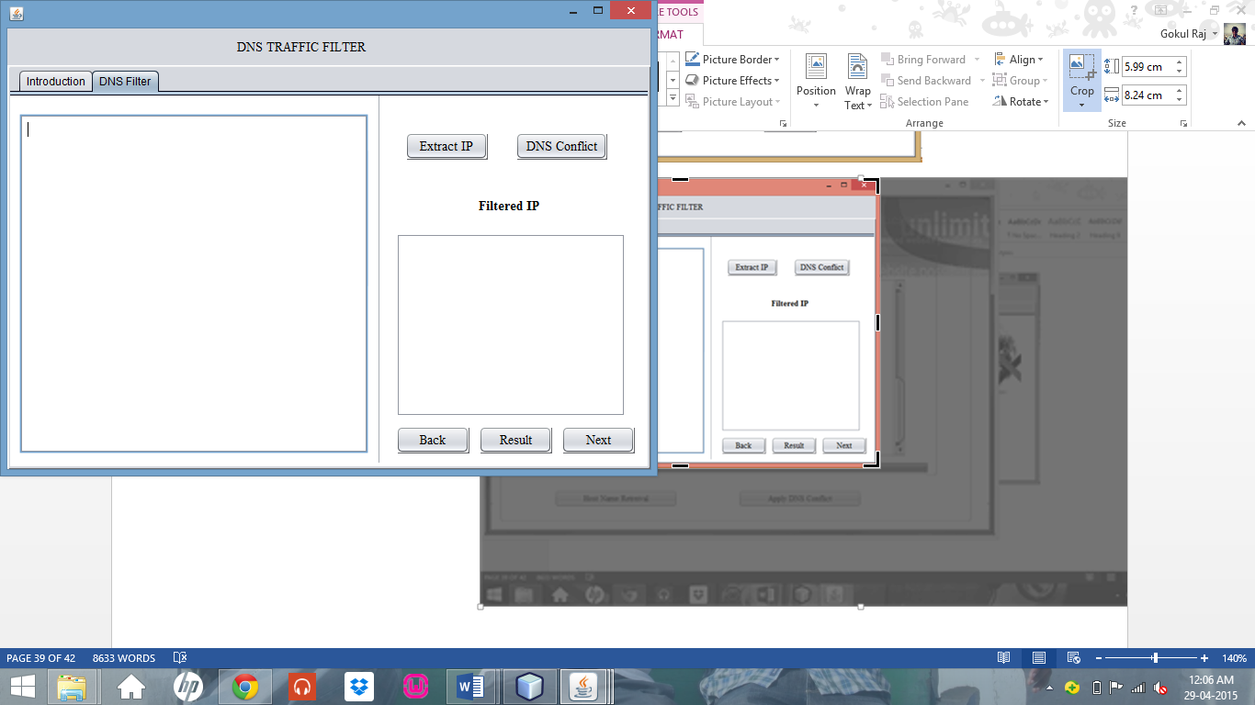

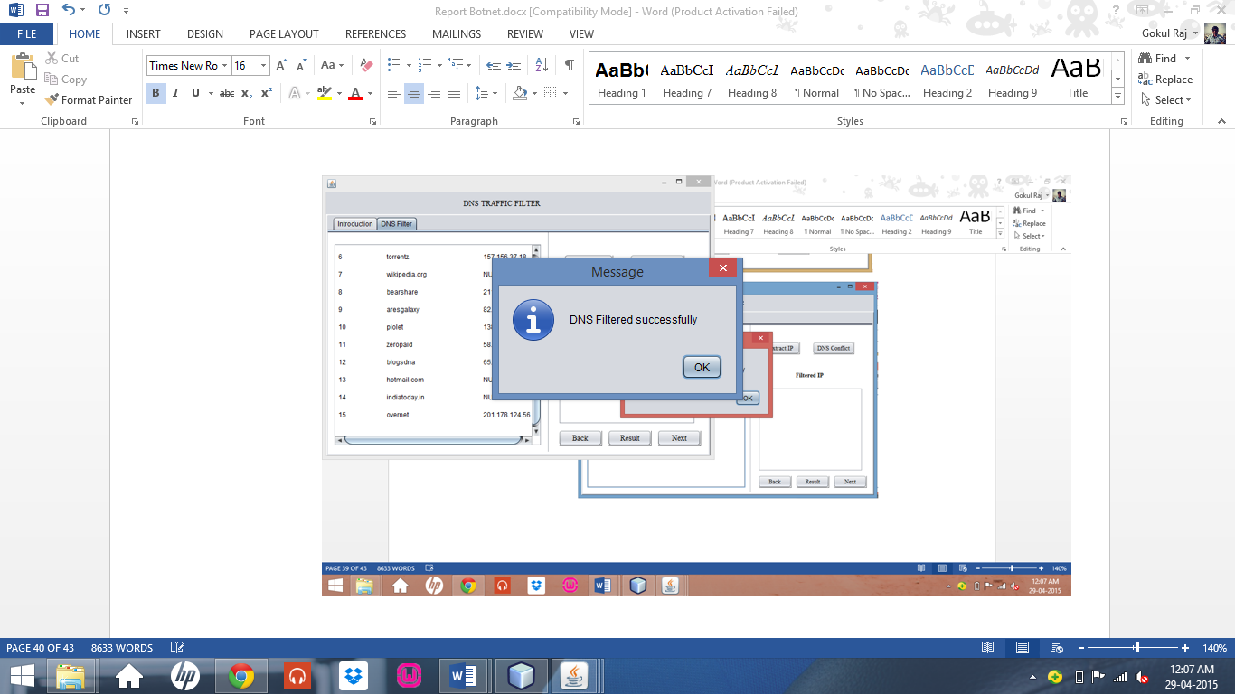

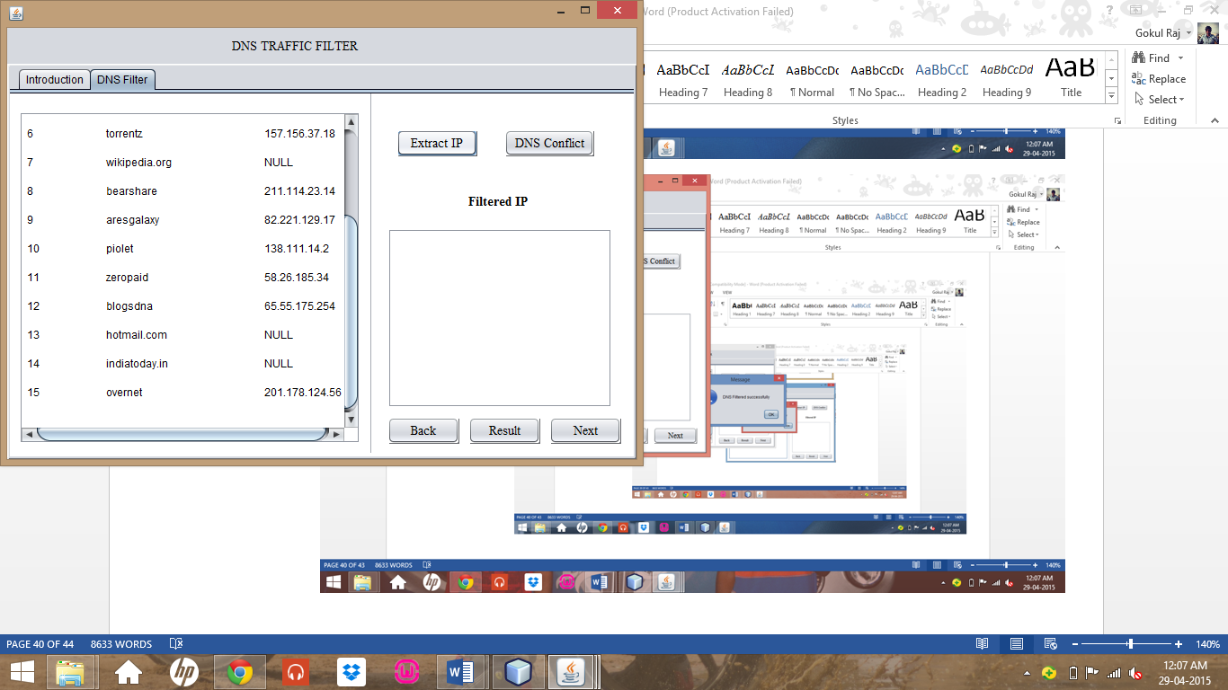

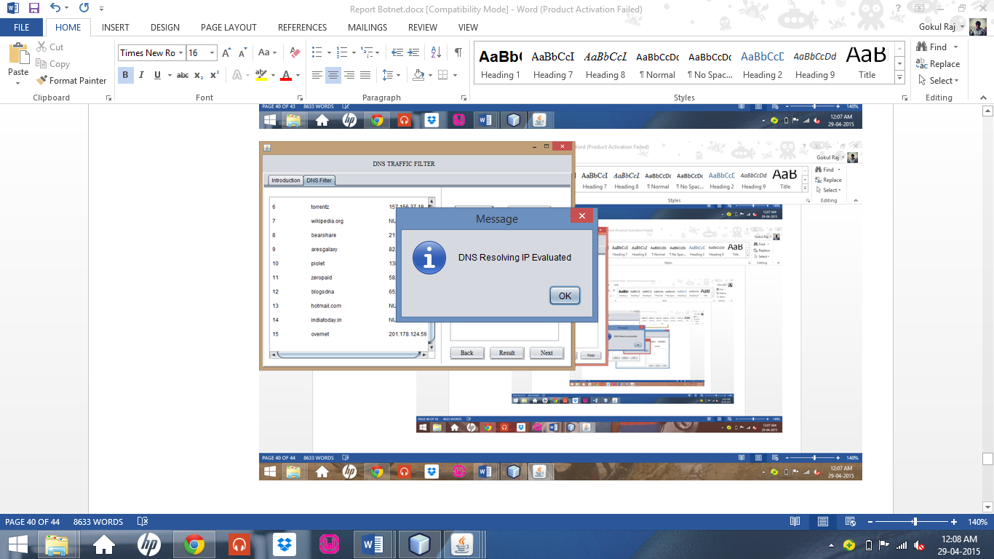

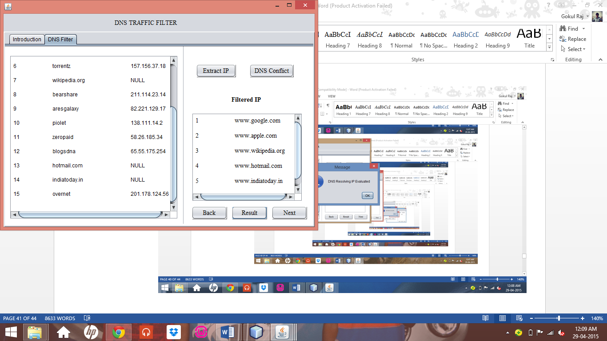

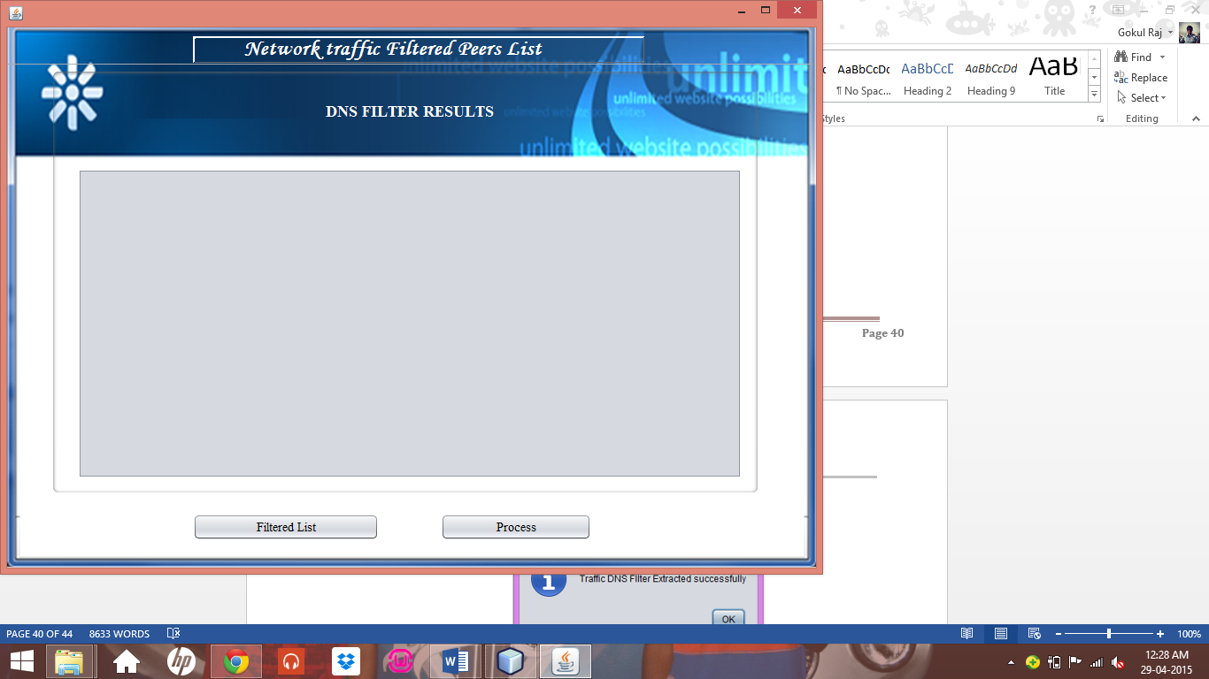

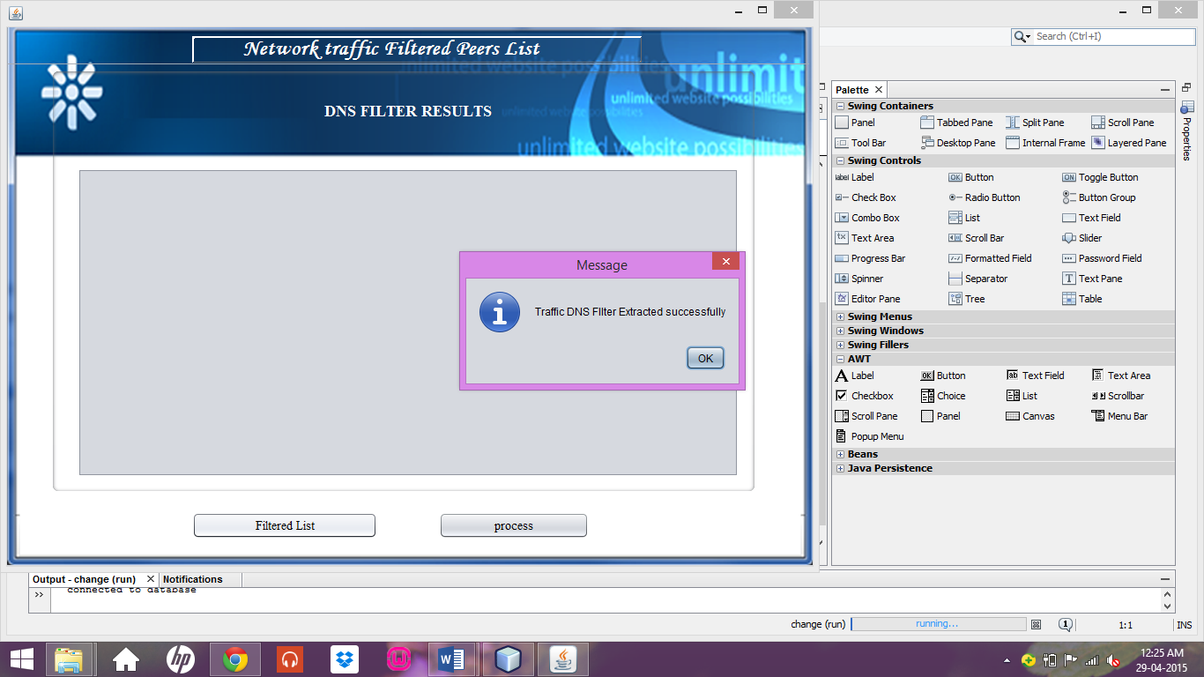

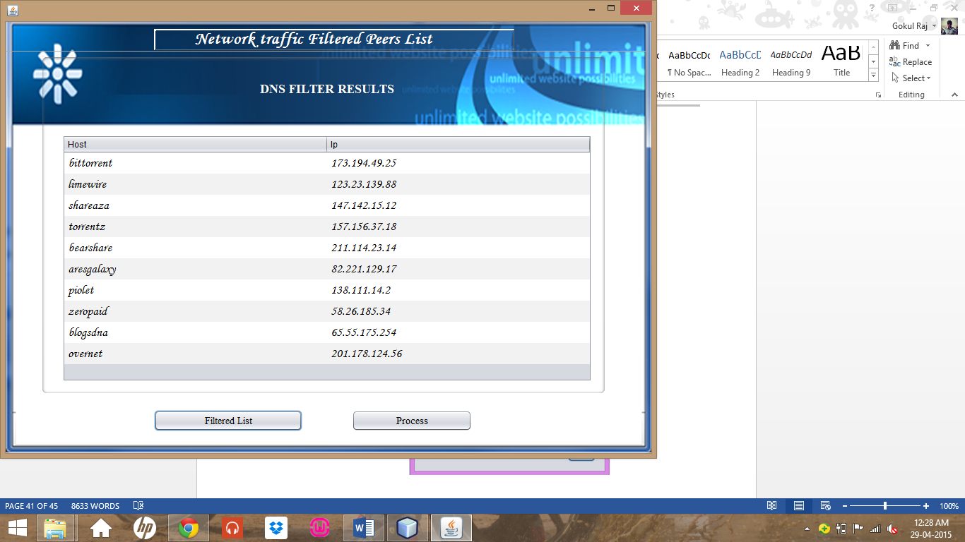

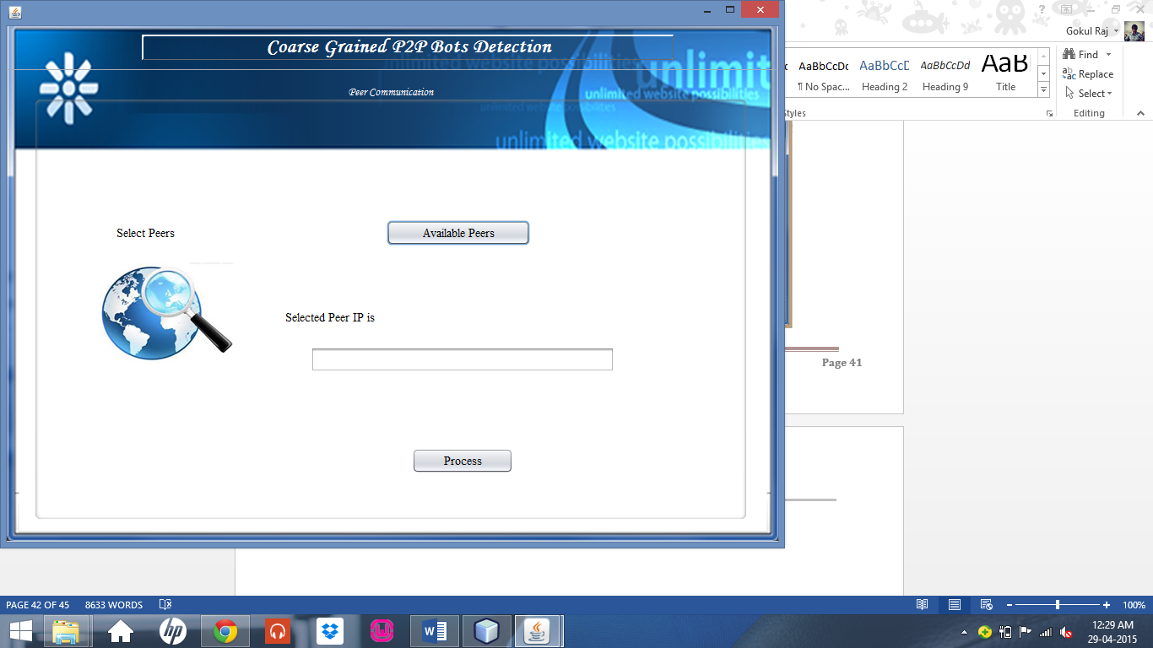

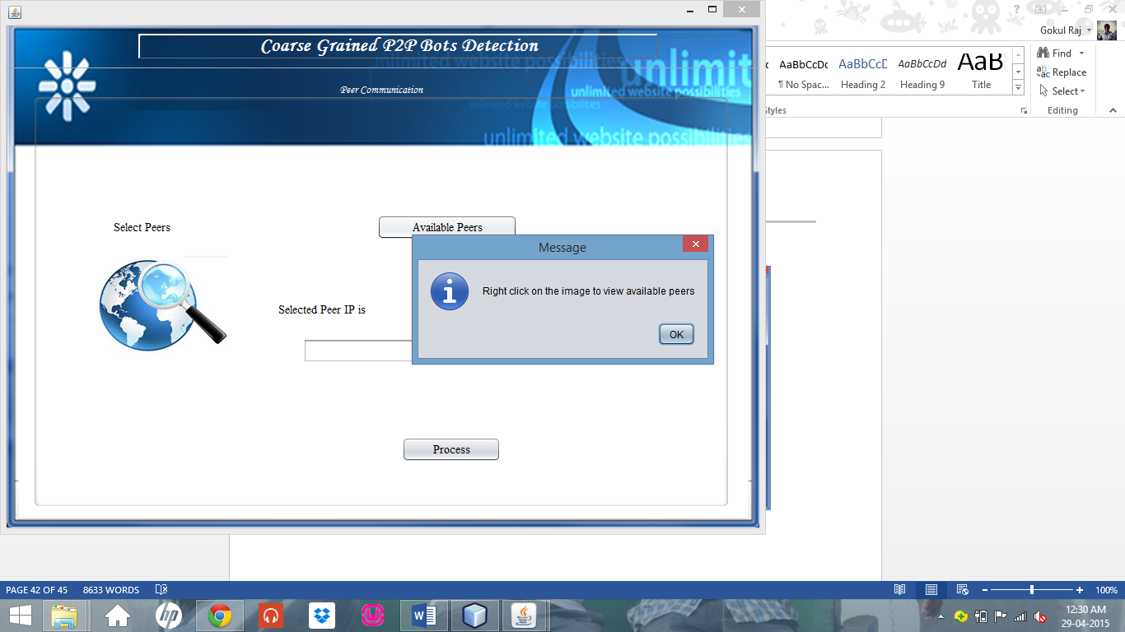

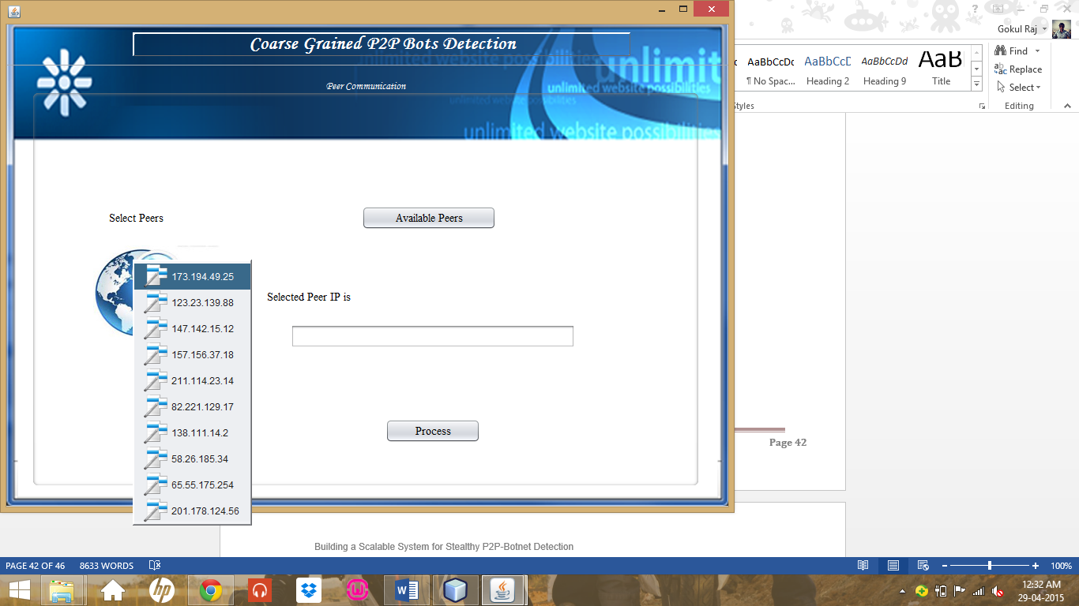

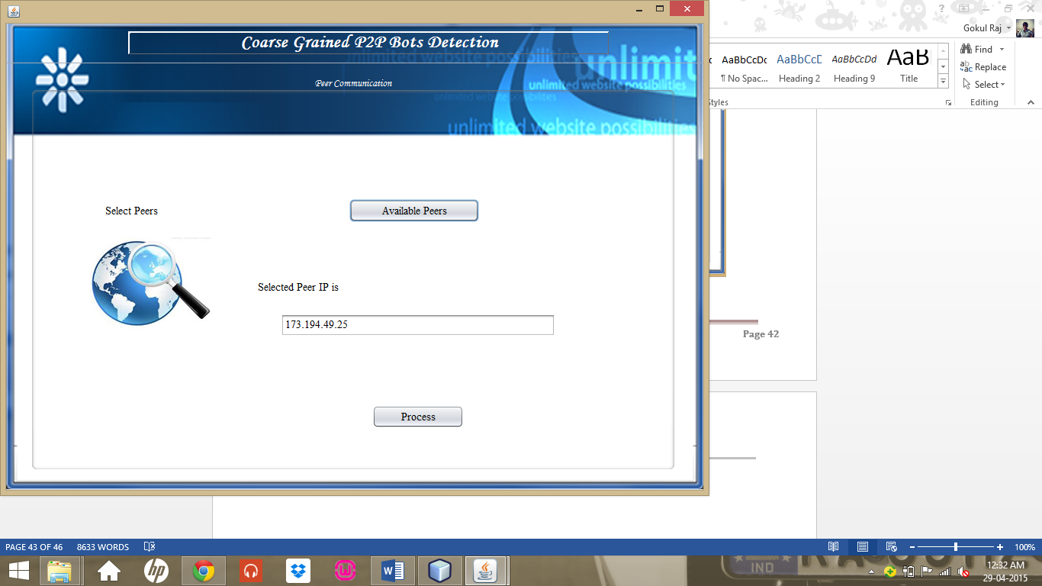

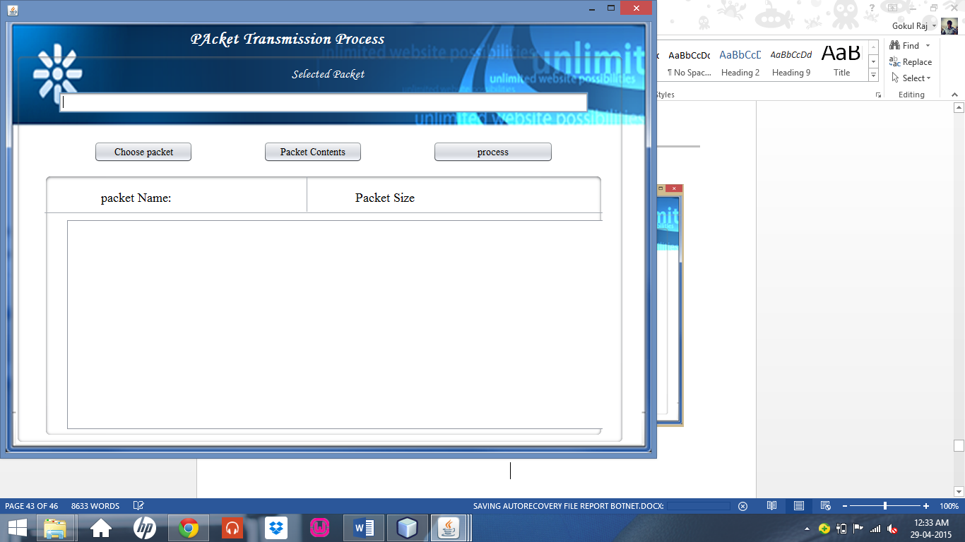

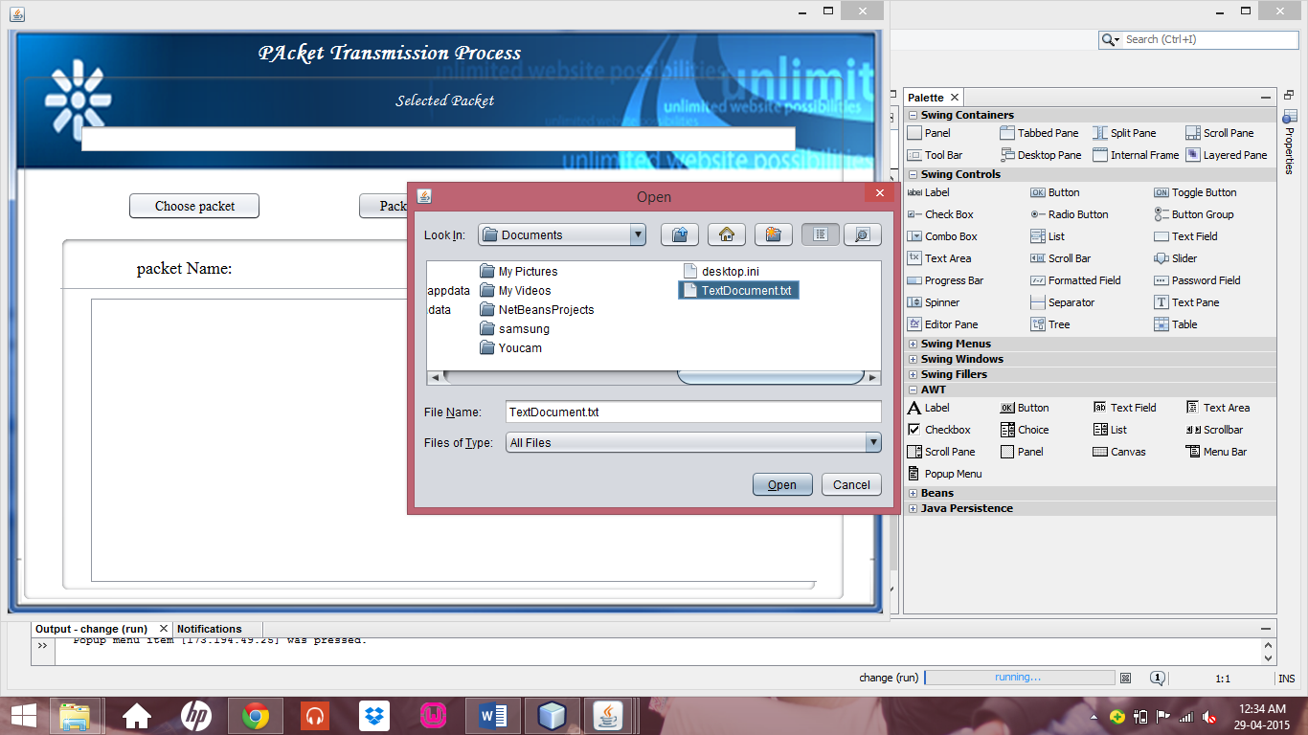

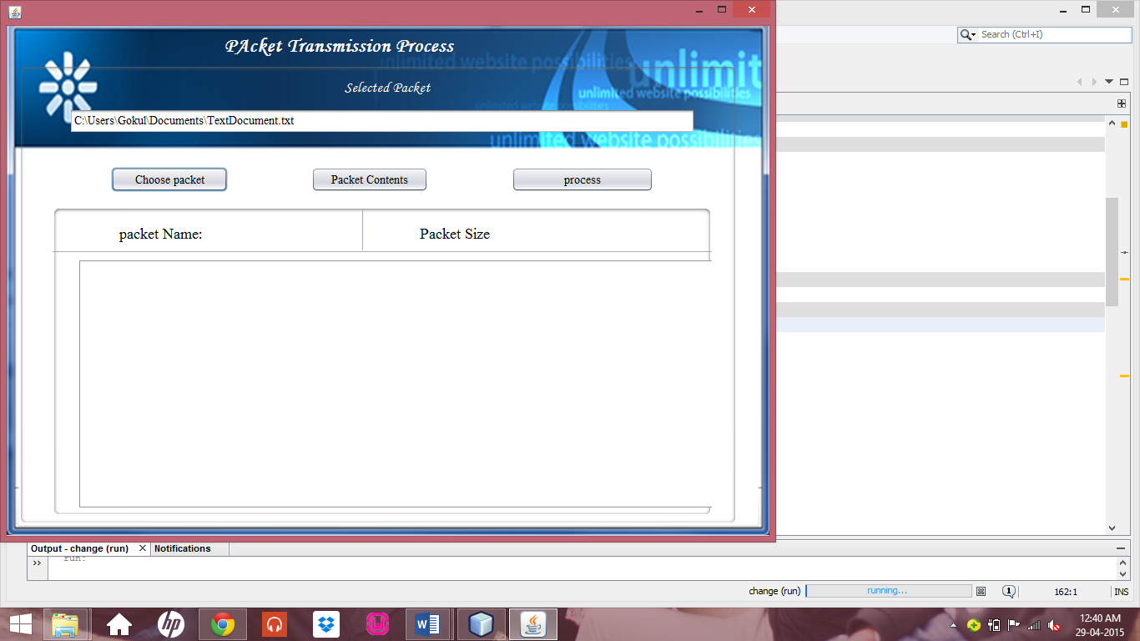

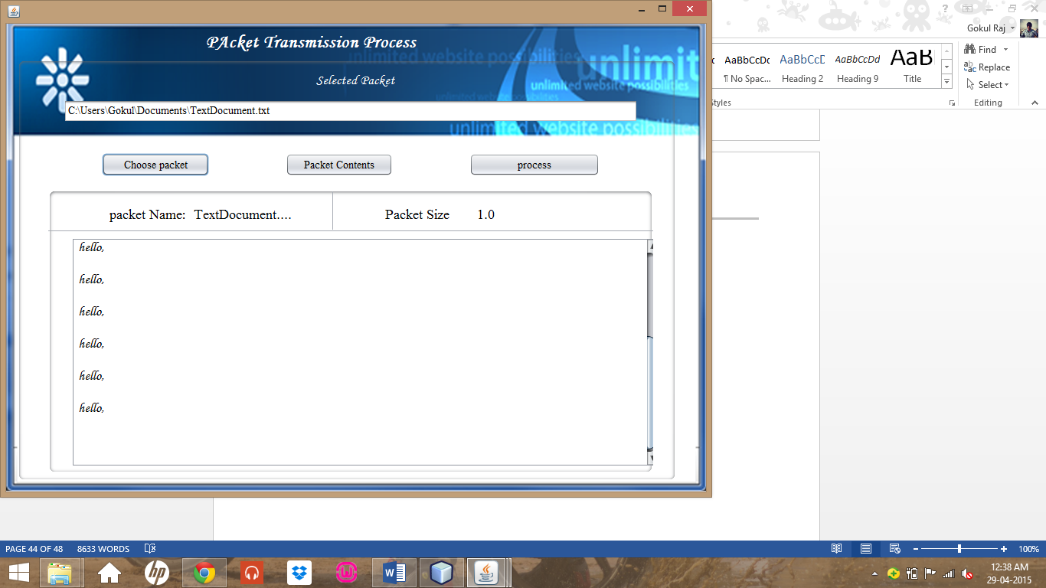

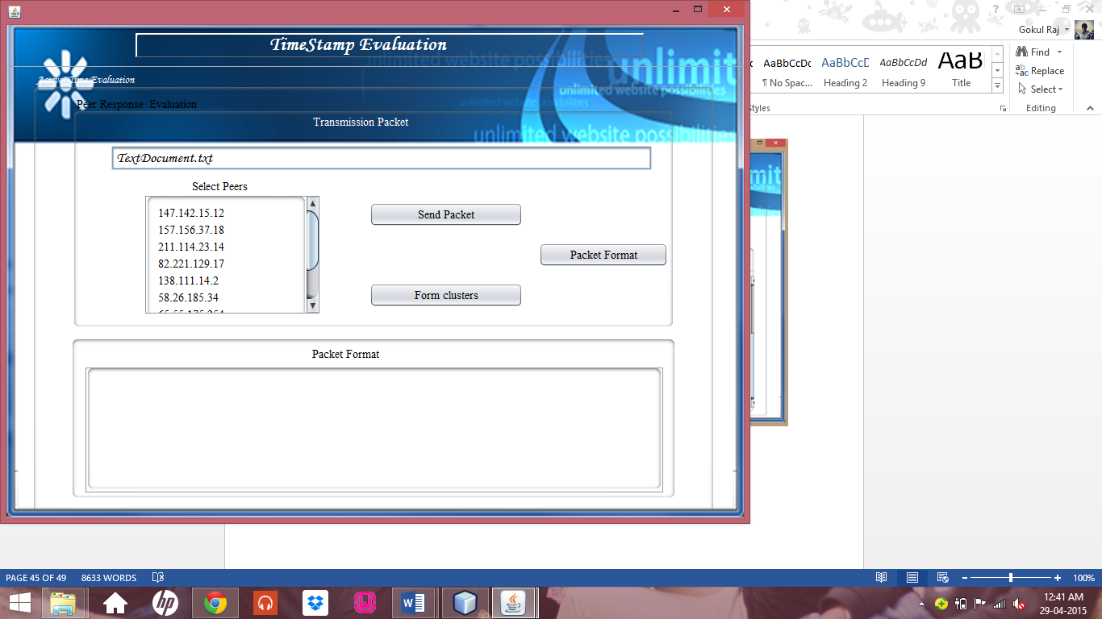

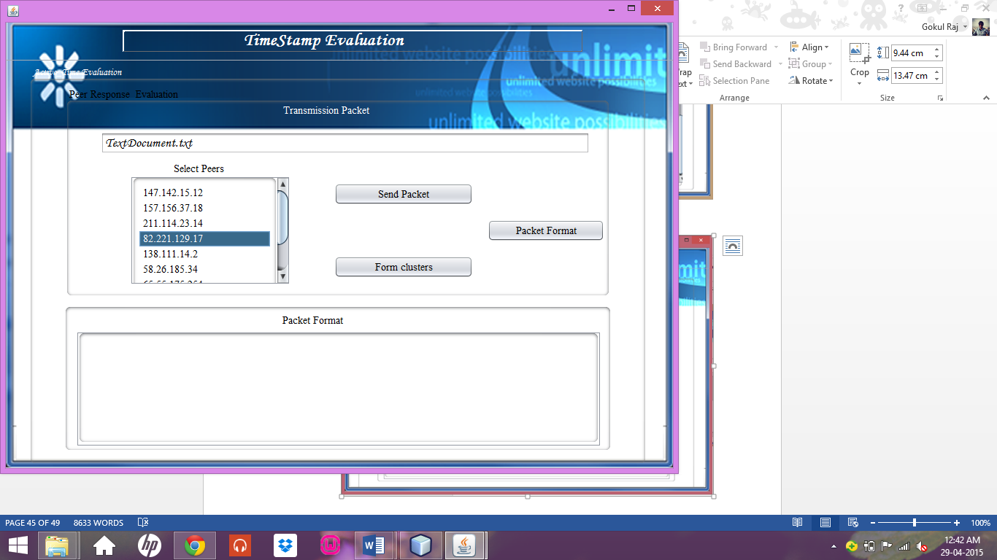

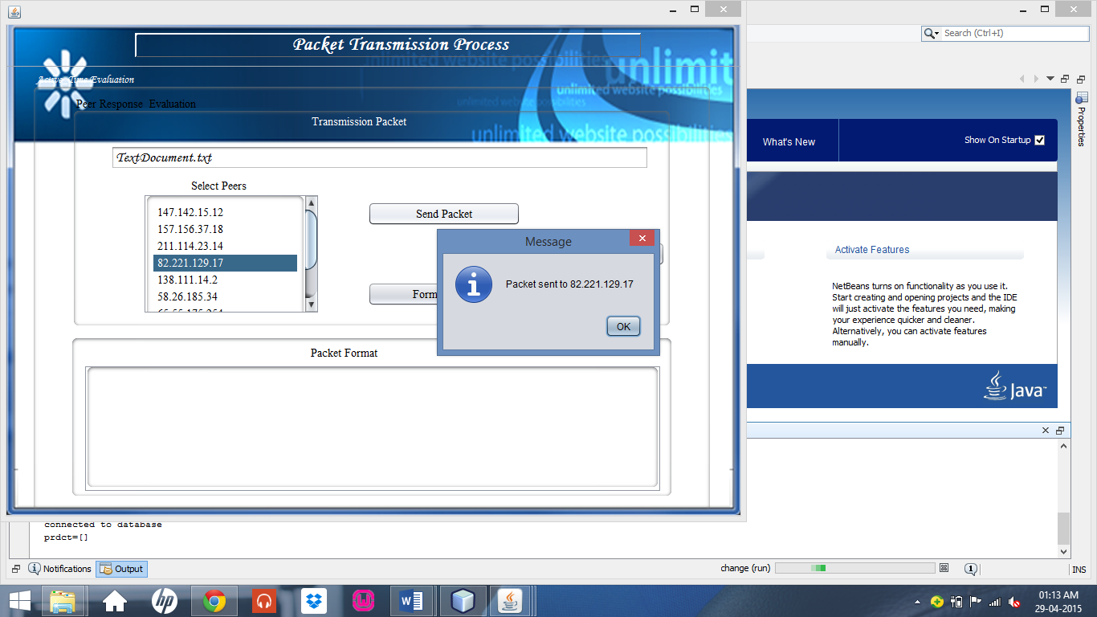

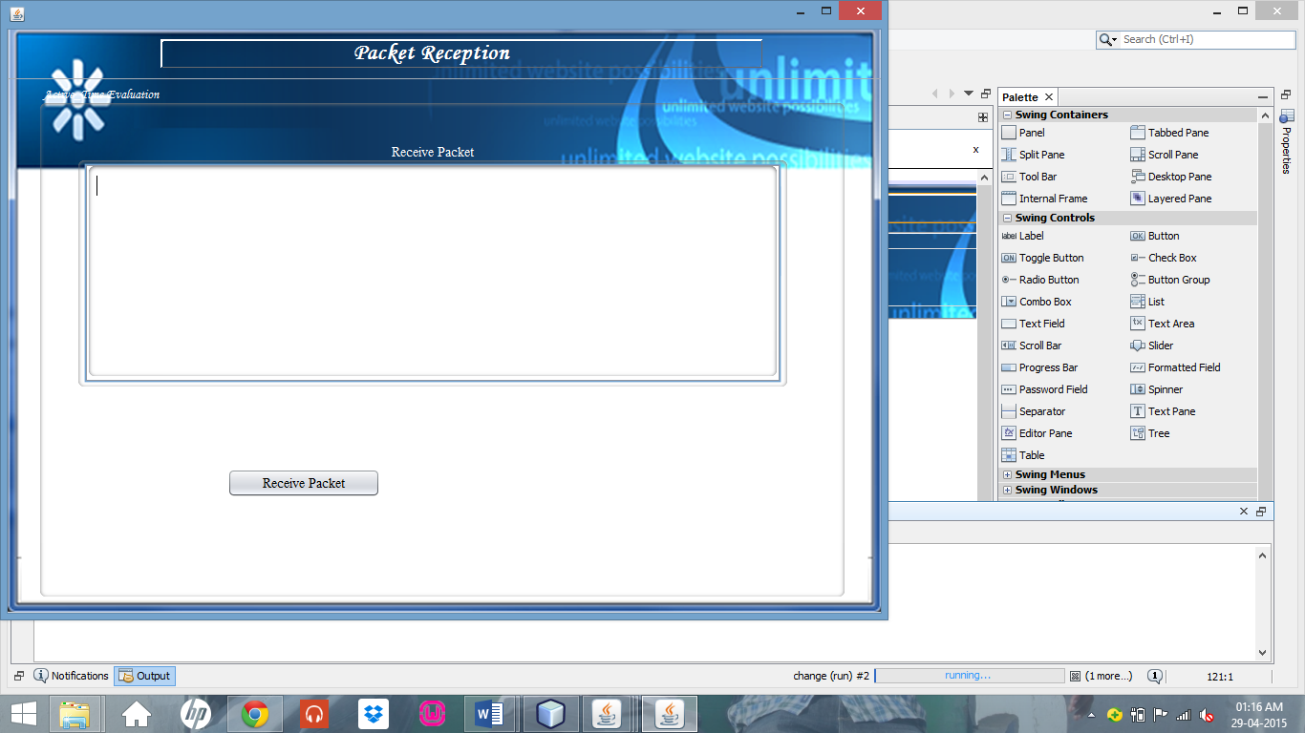

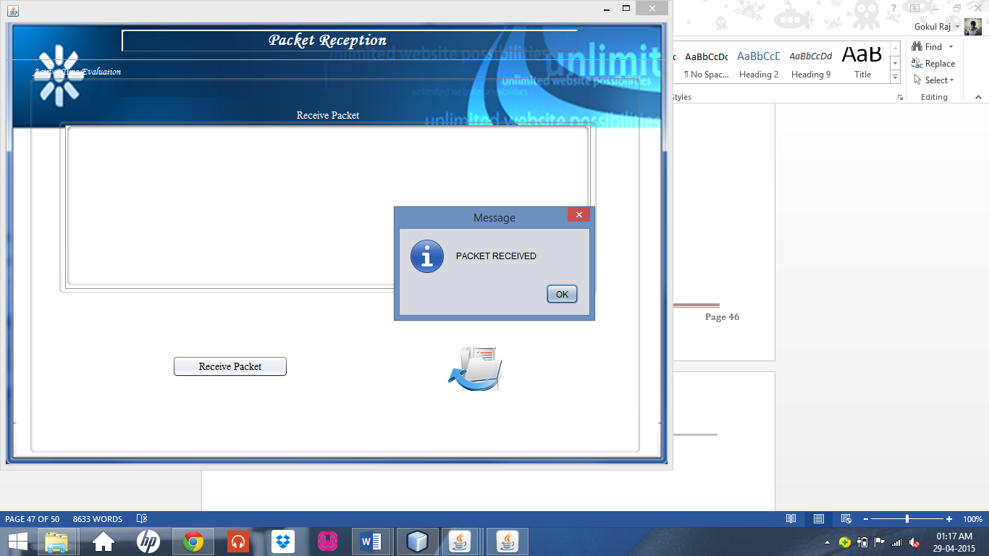

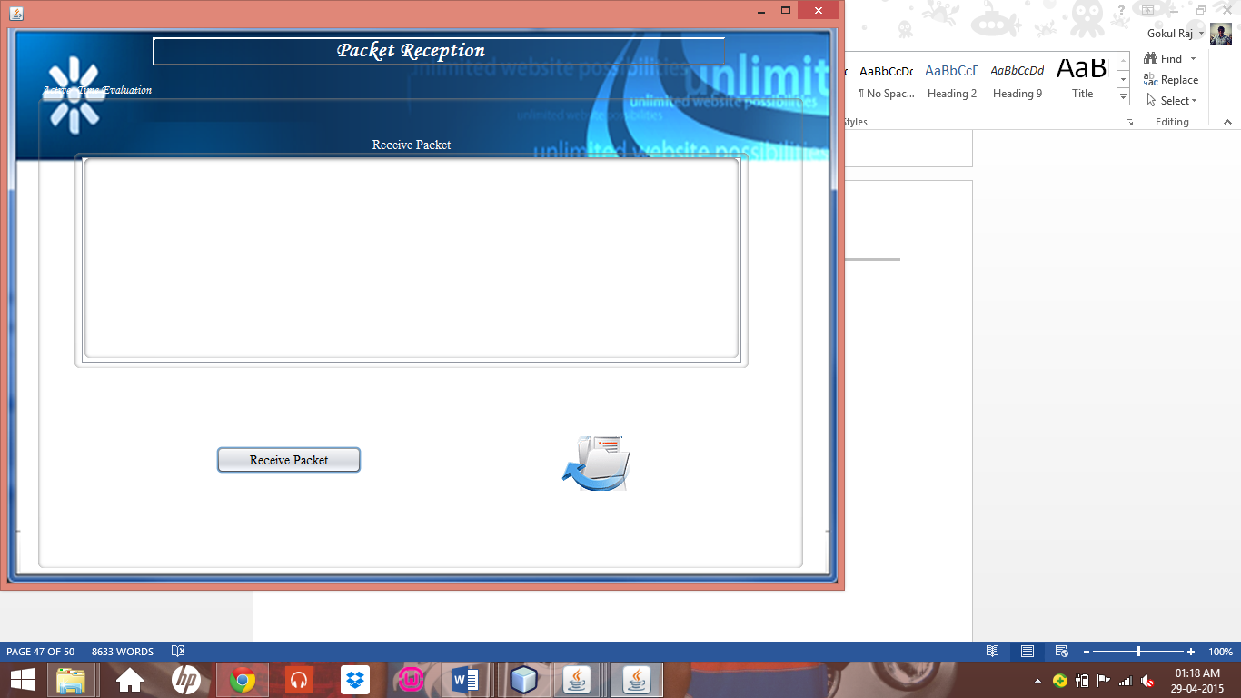

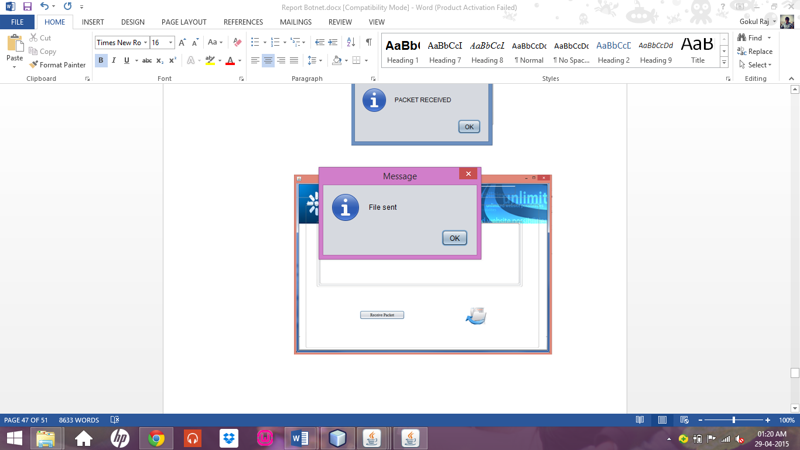

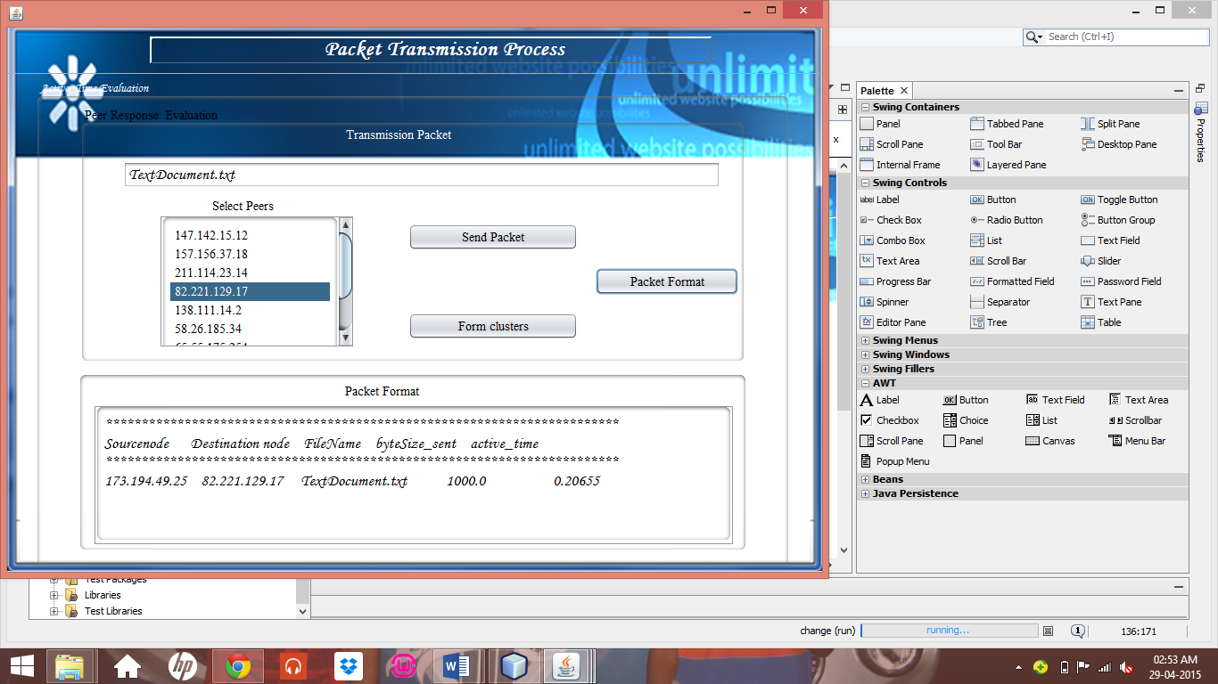

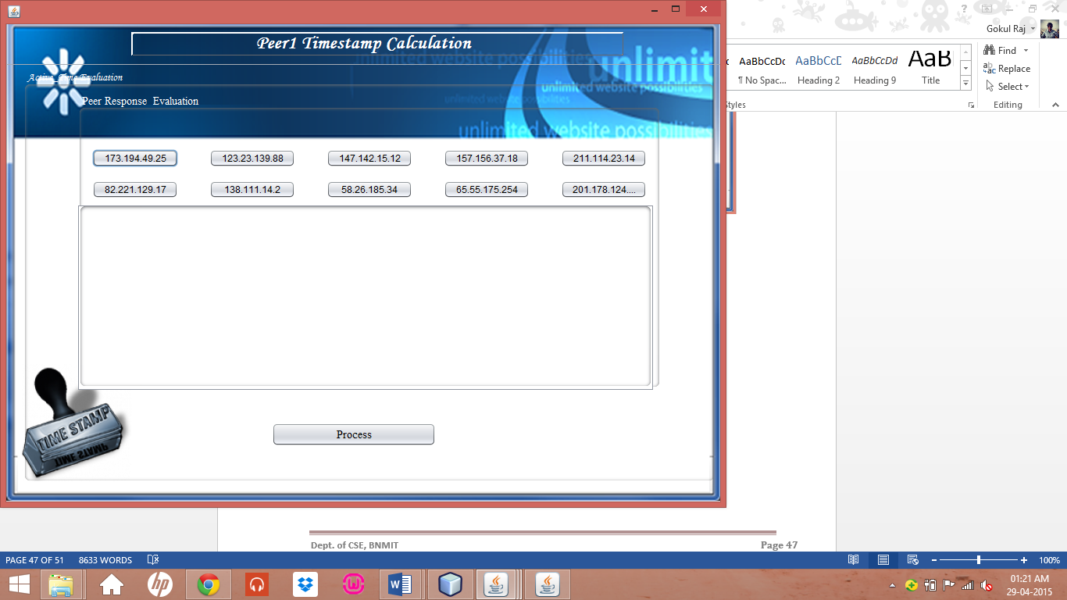

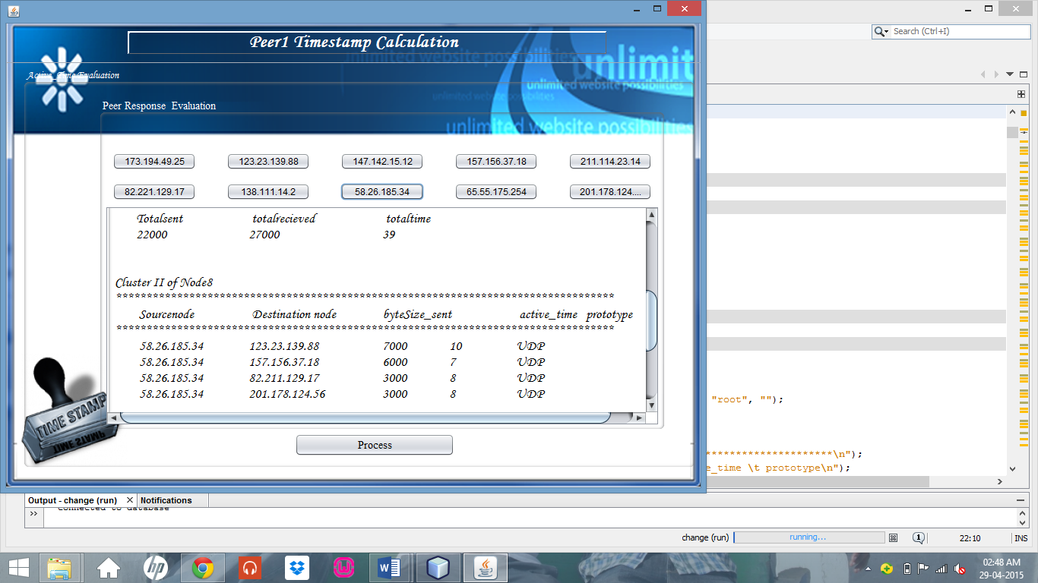

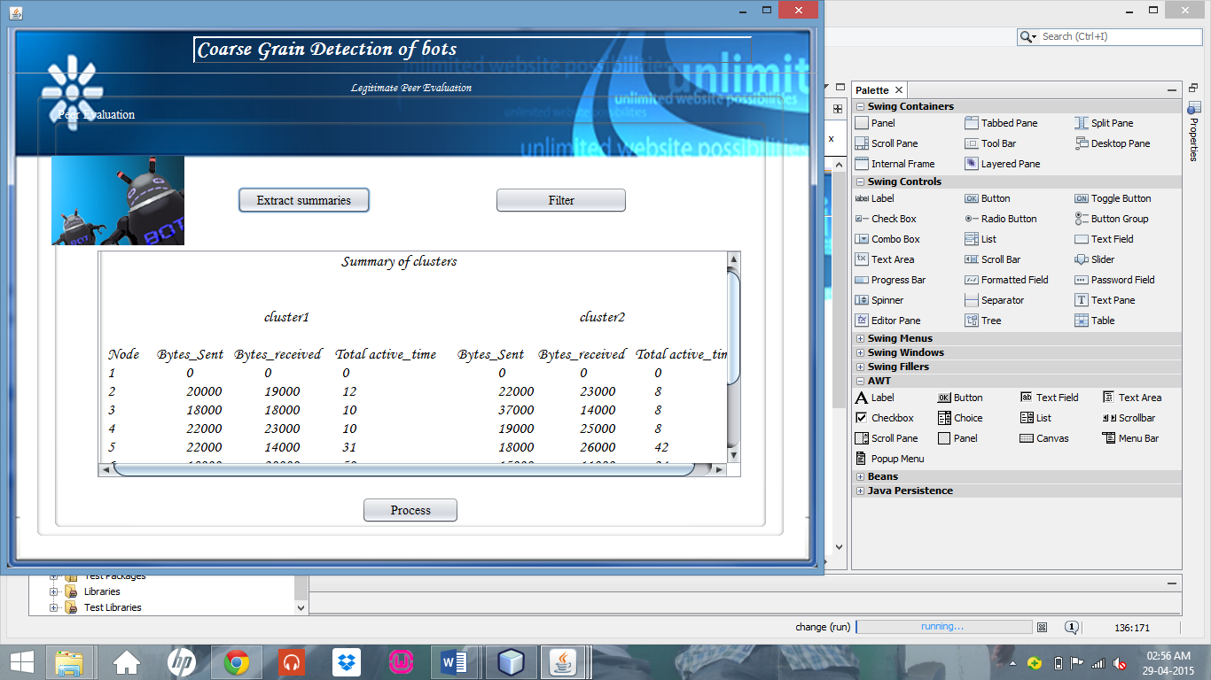

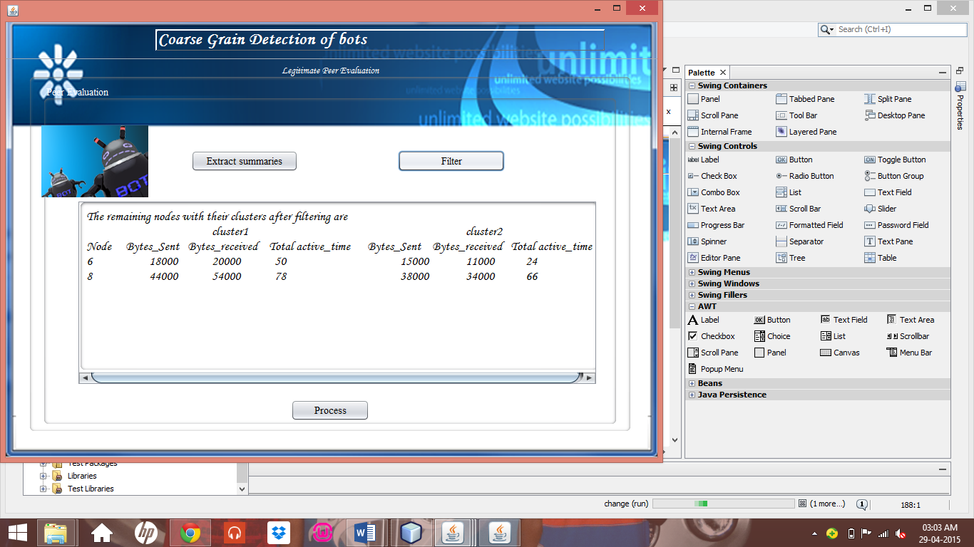

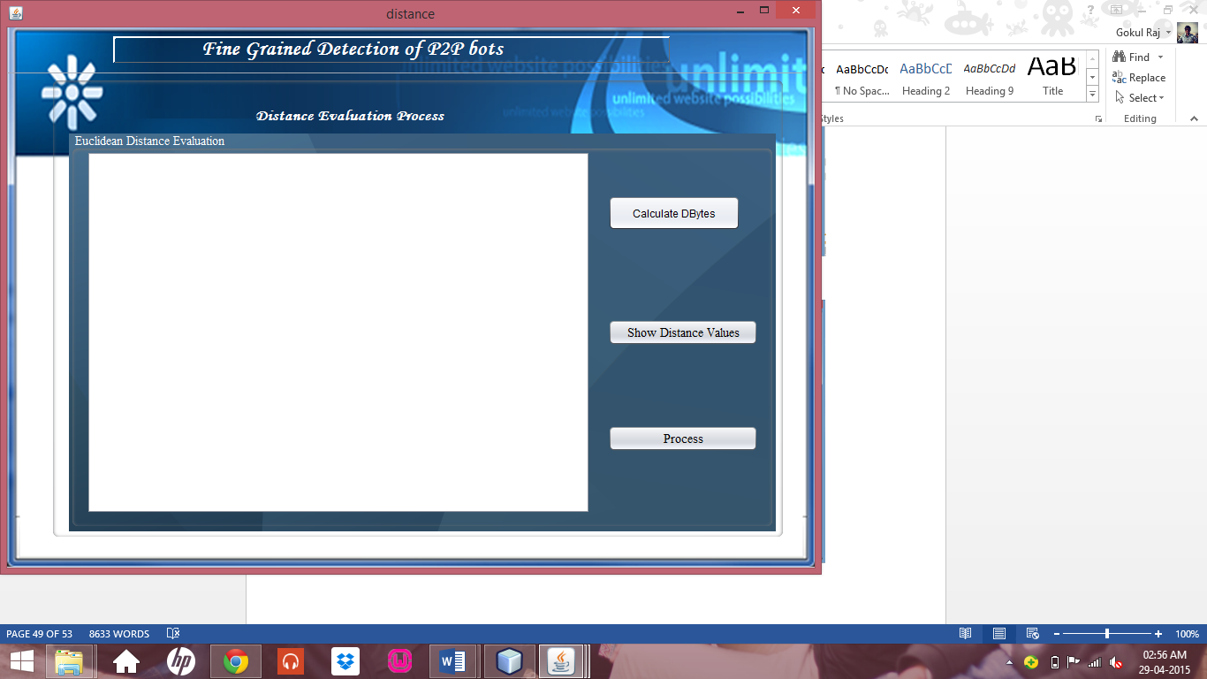

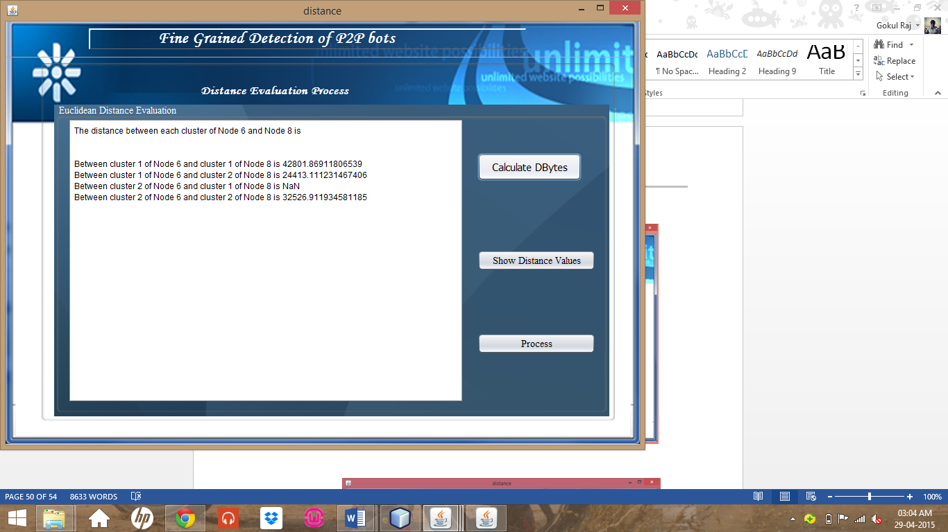

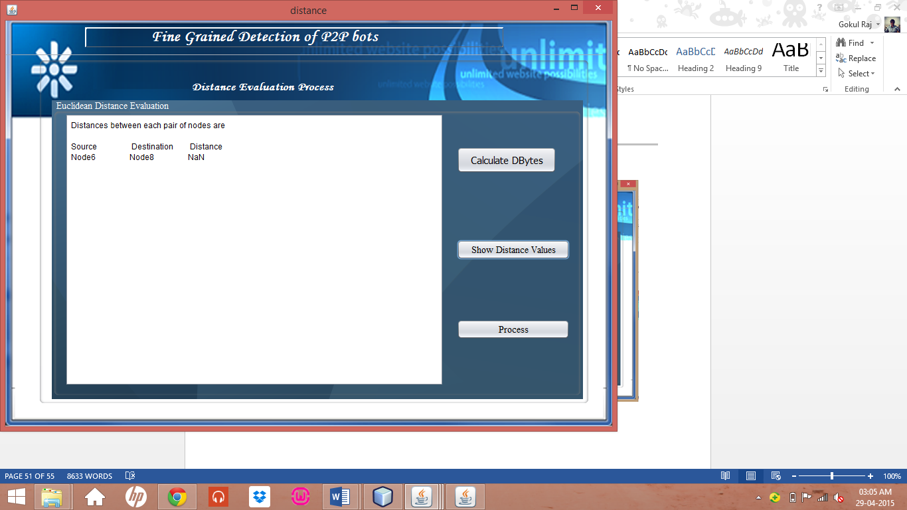

1. **Conclusions**

In this project, we presented a novel botnet detection system that can identify stealthy P2P botnets, whose malicious activities may not be observable usually. To accomplish this task, we derive statistical features of the P2P communications to first detect P2P clients and further distinguish between those that are part of legitimate P2P networks. A centralized Fine-Grained P2P Bot Detection Component can perform detection based on fingerprint clusters. As programmable network devices (e.g., switches) gain popularity, such improvement becomes practically feasible. And also identify the performance bottleneck of our system and optimize its scalability.

1. **FUTURE ENHANCEMENT**

The system aims to boost the effectiveness of existing P2P botnet detection by detecting P2P botnets in two challenging scenarios:

1. Botnets perform stealthy attacks that are extremely hard to identify in the network traffic
2. Bot infected hosts also run legitimate P2P applications.

**11.References**

* G. Sinclair, C. Nunnery, and B. B. Kang, “The waledac protocol: The how and why,” in Proc. 4th Int. Conf. Malicious Unwanted Softw., Oct. 2009, pp. 69–77.
* Y. Zhao, Y. Xie, F. Yu, Q. Ke, and Y. Yu, “Botgraph: Large scale spamming botnet detection,” in Proc. 6th USENIX NSDI, 2009, pp. 1–14.
* G. Gu, R. Perdisci, J. Zhang, and W. Lee, “Botminer: Clustering analysis of network traffic for protocol- and structure-independent botnet detection,” inProc. USENIX Security, 2008, pp. 139–154. T.-F.
* Yen and M. K. Reiter, “Are your hosts trading or plotting? Telling P2P file-sharing and bots apart,” inProc. ICDCS, Jun. 2010, pp. 241–252.
* S. Nagaraja, P. Mittal, C.-Y. Hong, M. Caesar, and N. Borisov, “BotGrep: Finding P2P bots with structured graph analysis,” inProc. USENIX Security, 2010, pp. 1–16.
* T. Holz, M. Steiner, F. Dahl, E. Biersack, and F. Freiling, “Measurements and mitigation of peer-to-peer-based botnets: A case study on storm worm,” in Proc. USENIX LEET, 2008, pp. 1–9.
* D. Stutzbach and R. Rejaie, “Understanding churn in peer-topeer networks,” in Proc. 6th ACM SIGCOMM Conf. IMC, 2006, pp. 189–202.